

**SCHOOL OF COMPUTING**

**UNIVERSITI UTARA MALAYSIA**

**PROGRAMMING 1**

**STIA 1113**

**FIRST SEMESTER SESSION 2021/2022 (A211)**

**TOPIC: BANK**

|  |  |  |
| --- | --- | --- |
| NO | NAME | MATRIC NUMBER |
|  | NOR AISYAH BINTI ABD HALIM | 286982 |
|  | NUR ANIS SHAFIQAH BINTI MAZLAN | 286987 |
|  | MUHAMMAD AFIQ IMRAN BIN AZIZAN | 286997 |
|  | MUHAMMAD YASRI BIN ROSLAN | 287021 |
|  | MUHAMMAD AIMIL DANIEL BIN LATIF | 287056 |

**TABLE OF CONTENT**

|  |  |  |
| --- | --- | --- |
| **1.0** | **Background of Project** |  |
|  | 1.1 Business loan | **1** |
|  | 1.2 Personal account | **2** |
|  | 1.3 Credit card | **3** |
|  | 1.4 Housing loan | **4** |
|  | 1.5 Investment | **5** |
| **2.0** | **Program descriptions** |  |
|  | 2.1 Main menu | **6-7** |
|  | 2.2 Business loan | **8-15** |
|  | 2.3 Personal account | **16-25** |
|  | 2.4 Credit card | **26-34** |
|  | 2.5 Housing loan | **35-42** |
|  | 2.6 Investment | **43-46** |
| **3.0** | **Code** |  |
|  | 3.1 Main menu | **47** |
|  | 3.2 Business loan | **48-50** |
|  | 3.3 Personal account | **51-54** |
|  | 3.4 Credit card | **55-58** |
|  | 3.5 Housing loan | **59-62** |
|  | 3.6 Investment | **63-64** |
| **4.0** | **Sample Run** |  |
|  | 4.1 Main menu | **65** |
|  | 4.2 Business loan | **66-68** |
|  | 4.3 Personal account | **69-71** |
|  | 4.4 Credit card | **72-74** |
|  | 4.5 Housing loan | **75-77** |
|  | 4.6 Investment | **78** |

**1.0 Background of Project**

Our project is to develop an application system for the bank. Our system offers a variety of services, including business loan, personal account, credit card, housing loan and investment. This will help our customers in fulfilling their needs. Moreover, we have discussed renaming our bank as 'GEMpak BANK'.

**1.1 Business loan**

The first service in GEMpak Bank is Business Loan. This service will help the user to get business loans. There are 2 types of application methods which are by online and by branch application. This will be easier for the user because for small loan, they can apply the loan online and they do not waste their time. The system will ask 3 information, personal information, business information and loan information. The system also will calculate monthly payment using the formula below:

(P * i) / (1 - ( 1/ (( 1 + i ) ^ ( n *12)))

where

P = loan amount

i = monthly interest in decimal

n = loan term in month

The system also will show the record that has been input by the user.

|  |  |  |  |  |  |
| --- | --- | --- | --- | --- | --- |
| Name | Phone Number | Account number | Loan amount (RM) | Monthly payment (RM) | Total payment (RM) |
| aisyah | 01156533696 | 36021547896253 | 150000 | 2085.02 | 17142.03 |
| akim | 01478253695 | 12547896302154 | 70000 | 973.01 | 81732.95 |

**1.2 Personal account**

The second service is Personal account. This service will be a system that help user to transfer their money by using DuitNow. It also will ask user information related to the recipient bank name, recipient account, recipient name, recipient reference, and amount that a user wants to transfer. This program will lead the user through the process of transferring money and will calculate the total amount transmitted and any fees that may be charged based on the user's request. The user will also be given a list of gifts from which to choose in order to celebrate the new year. Before deciding on their gift, the user will be asked to play a guessing game.

|  |  |  |
| --- | --- | --- |
| OPTION |  | FORMULA |
| DuitNow | Recipient bank name : Maybank  Recipient account :72671932  Recipient name : Ali Bin Abu  Recipient reference : Loan  Amount : RM 500.00  *Fee = 2%  *RM 1.00 will be charged. | Total amount have been charged :  RM 511.00  FORMULA :  500 + (500*0.02)+1.00 = RM 511.00 |

List Of Gifts:

|  |
| --- |
| **GIFTS** |
| 1. Notebook + Calendar |
| 1. Bag + Calendar |
| 1. Tumblr Bottle + Calendar |
| 1. We Bare Bear + Calendar |
| 1. Colour Pencil + Calendar |

**1.3 Credit Card**

The third service is credit card. This system will help people to determine how much balance on your credit card based on your credit card choosing and how much you need to pay up in future.

|  |  |  |
| --- | --- | --- |
| Credit card type 1 | Credit card type 2 | Credit card type 3 |
| Balance = 40000– total payment | Balance=80000–total payment  Cashback = (0.07) (Petrol) | Balance= 65000 – total payment  Cashback = (0.5) (airplane ticket) +  (0.5) (Hotel Booking) |

This system will calculate how much you need to pay for a month base on Investment, rate and Paid amount

Calculation:

-Percentage interest = (Investment * rate) / (12)

-Interest = (percentage interest / 100)

-Paid amount = Interest + investment

-balance = Paid amount – Interest

This system will repeat many times based on how many users want to put it for probability.

**1.4 Housing loan**

Last but not least, the housing loan system in GEMpak Bank will help the borrower to calculate the loan amount according to how much they want to borror, interest rate and the number of years. The housing loan system will come out with the monthly payment and the total of payment.

|  |  |  |  |
| --- | --- | --- | --- |
| Housing loan | Rm 249000 | 3.80 % | 30 years |

The calculation

1.Principal = Rm 249000

2.Interest rate = 3.80/12/100

3.Number of years = 30 * 12

4.The monthly payment

249000 * 0.31 (1+0.31)*30 years

(1+0.31) 30 years - 1

5.The total payment

Total monthly payment * term of years * 12

**1.5 Investment**

Lastly, the fifth service in GEMpak Bank is the Investment. Our bank is provided term-investment which can be invested in the short period with minimum 3 months and maximum 12 months. The table below shows the information about this investment.

|  |  |  |  |
| --- | --- | --- | --- |
| **Investment Amount** | RM 1,000- RM 10,000 | RM 10,001- RM 30,000 | RM 30,001- RM 50,000 |
| **percentage of Net Return to customer** | 3.2% | 3.8% | 4.2% |

**Formula**

- Profit payable to cust = Investment amount * Percentage of return to customer * 30/365

- Accumulated profit = Profit payable to cust * investment tenure

- Total amount = Investment amount + accumulated profit.

**Calculation:**

- Profit payable to cust = Rm 30,000 x 4.20% x 30/365 = Rm 96.82

- Accumulated profit = Rm 96.82 x 3 = Rm 290.46

- Total amount = Rm 30,000 + RM 290.46 = Rm 30,290.46

So, here is an example of the calculation. Customers have to enter the amount of investment between RM1000 to RM50,000 and choose the investment tenure. So, in this system, customers have to follow the instructions one by one to get the real output which are firstly, they need to register, then do investment. For selection 3, customers have the choice either to look at future value or not. After that, print receipt and lastly exit system.

**2.0 Program Descriptions**

In program descriptions, we will explain to customers how to use our system.

**2.1 Main menu**

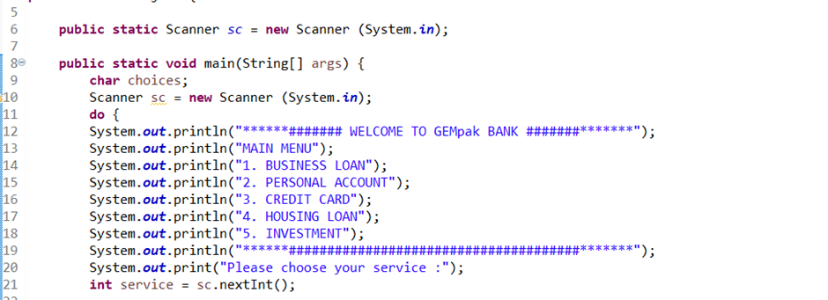

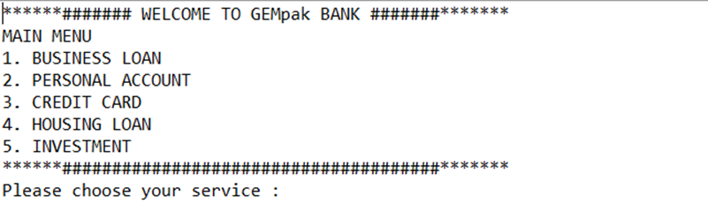

Firstly, once you run the system, the system will welcome the user to GEMpak bank. After that, the programme will display the list of main menus that our services provided for user to choose. The service we provided included business loan, personal account, credit card, housing loan and investment.

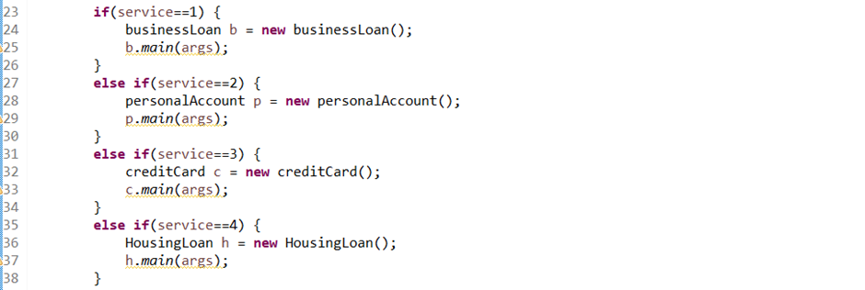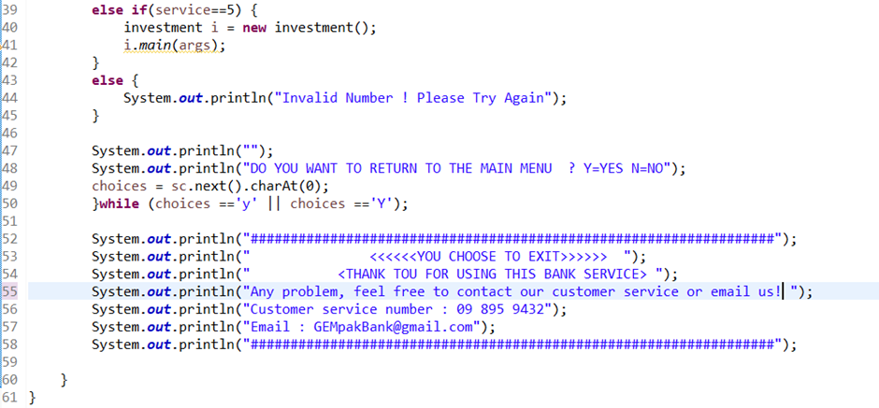

For the main menu, we use the if-else statement as a selection control structure. User will bring to the new web page based on the number user insert. For example, if user choose service ‘2’, the user will enter the personal account page while if user choose service ‘5’, user will enter the investment page.

**2.2 Business loan**

If you choose number 1, which is Business Loan, the system will list out a menu of business loan. There are 7 options in the menu which are information of Loan, type of application method, information about application method, the interest rate, input detail information, view record and the last one is exit from the system. 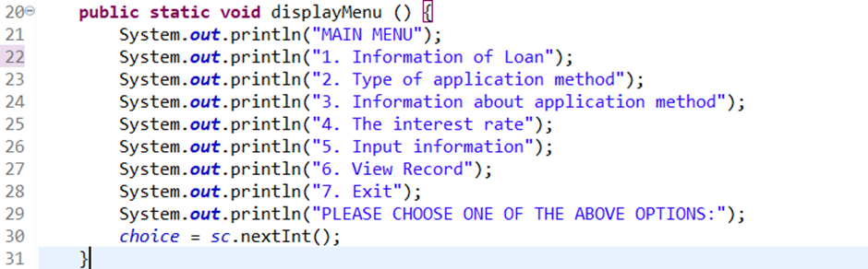

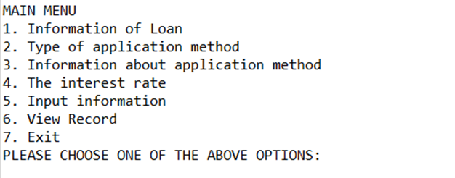

After that, you will see the information on the application method. There are 2 types of application methods that were provided from our bank service, which are by online application and by branch application. You also will be given further information about the application method.

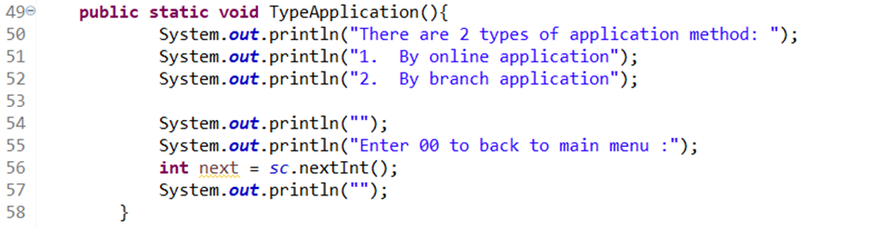

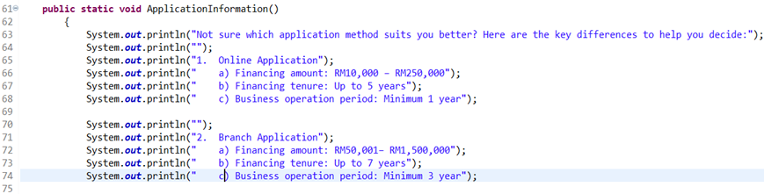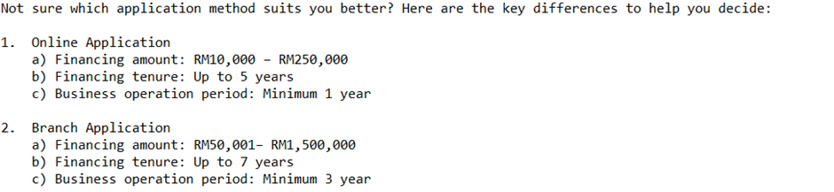

If you choose to input information, you will first be required to complete the personal details of the customer in order to proceed. About the personal details of the customer, you need to fill in the personal details such as name, IC number, phone number and also your account number.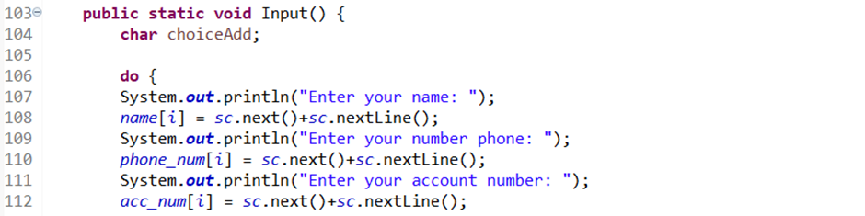

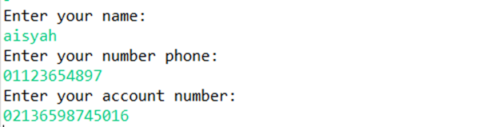

Then, you need to enter your business information such as business operation period and your business annual revenue or sales. If your operation period is more than 12 months and revenue or sales less than 25 million, you will enter loan information like amount of loan and financing tenure. On the other hand, the system will come out “Sorry, you did not qualify to make a business loan”.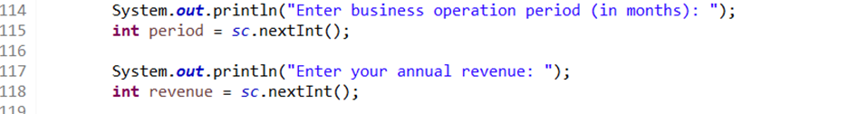

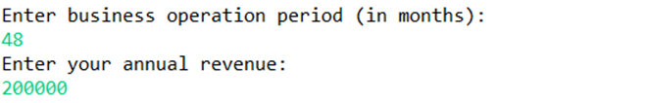

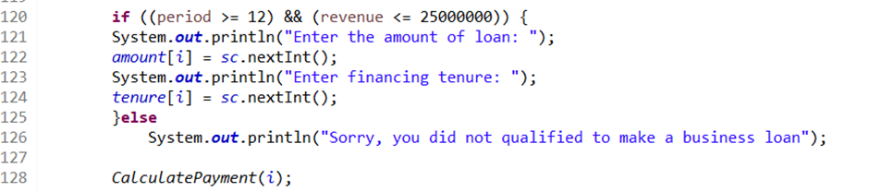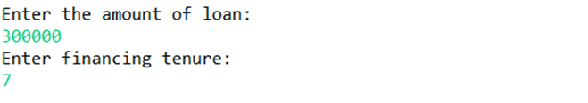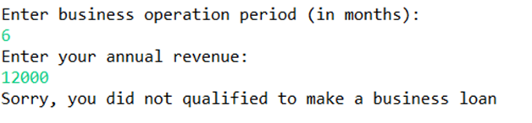

The system will calculate your monthly payment and total of your payment to the bank based on your amount of loan and financing tenure. The interest rate is 4.5%.

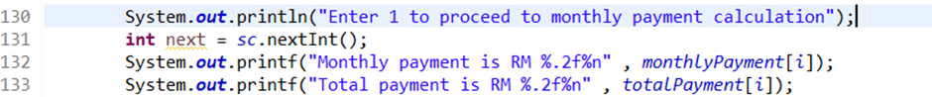

After that, the system will be asked that whether you want to enter another input or not. If you want to enter another input, you have to enter personal information, business information and loan information like before. If you choose not to enter another input, the system will show the menu again.

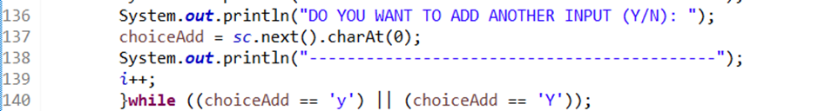

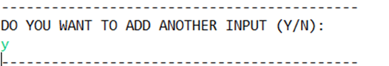

If you want to view record that you have enter before, you will choose 6 from the menu. In the record, there are name, phone number, account number, loan amount, monthly payment and total payment.

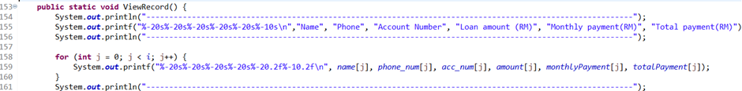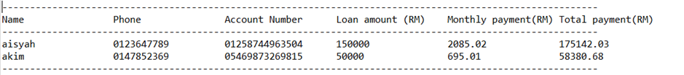

Lastly, when you exit from the system, there are information about if you have any problem you can contact our customer service.

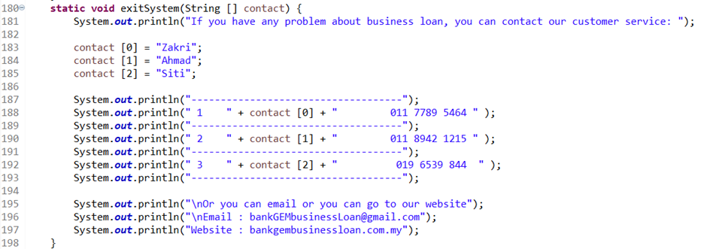

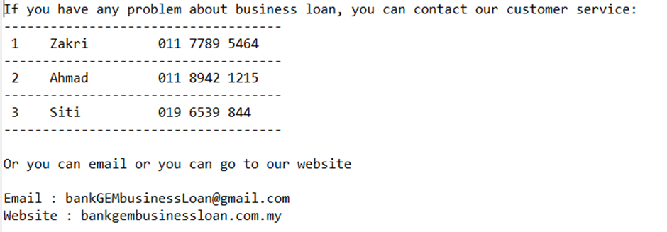

**Numerical Data and Expression**

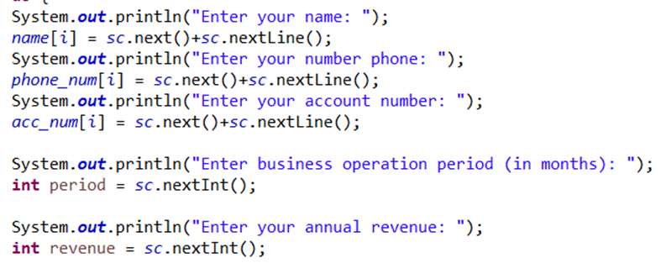

**Selection Control Structures**

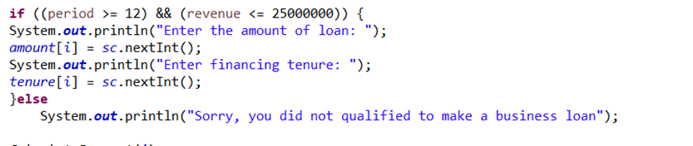

**Repetition Structure**

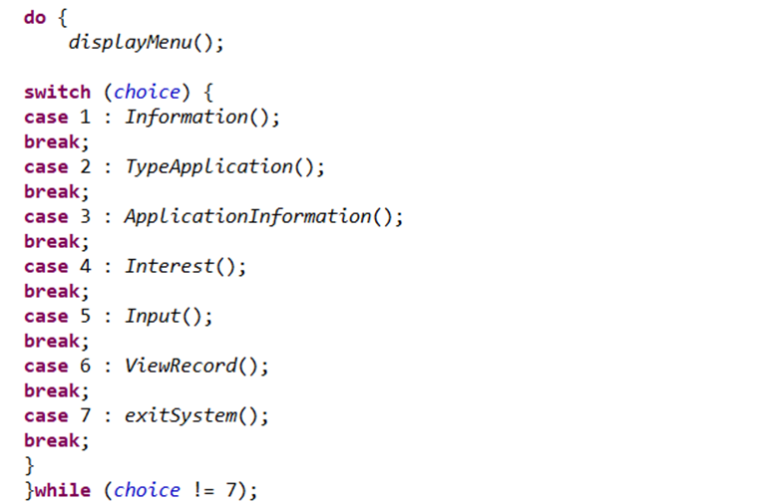

**Array**

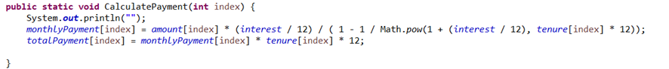

**Passing Array to Methods**

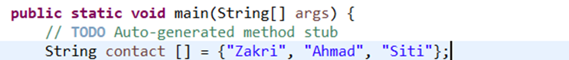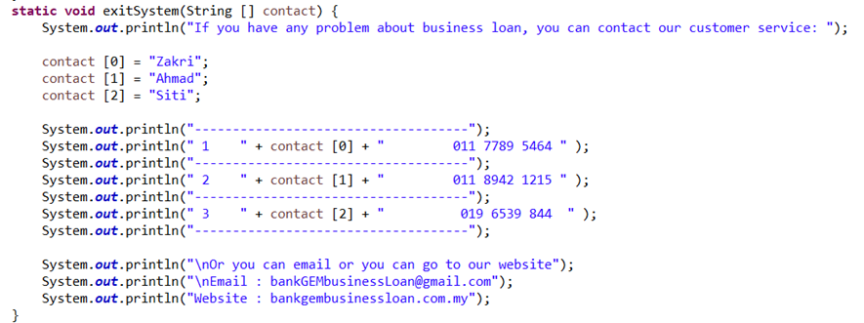

**Using Methods**

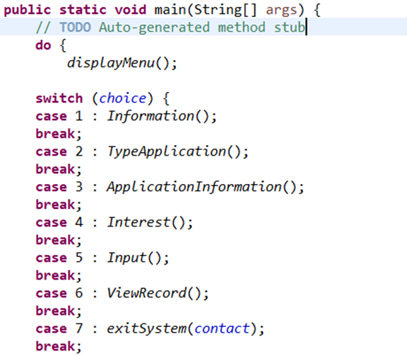

**2.3 Personal account**

After user pick service 2 for the personal account, user will be welcoming to the ‘GEMpak BANK’. User also need to choose the option given to enter into the web page.

1. If user choose 1, system will bring user to page registering new user. Then, user need to insert the information details like their full name, account number and number phone. After user insert all the details, user will be a new member in our GEMpak BANK. Then, the system will return to the main menu.

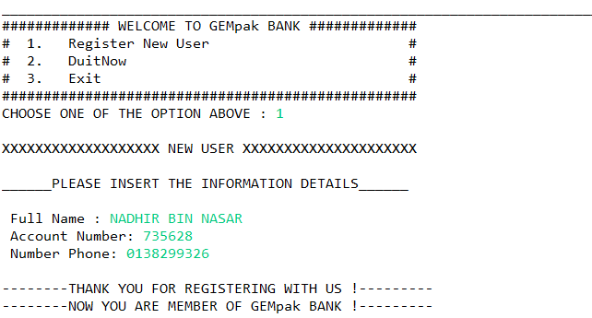

1. If user choose 2, system will bring user to page DuitNow for transferring the money from user account to another account. User need to insert their own account number and key in all the information details. After user insert the amount, our service will remind user that fee 2% and RM 1.00 will be charged for every transaction. Total amount that been charged will display after user choose to continue.

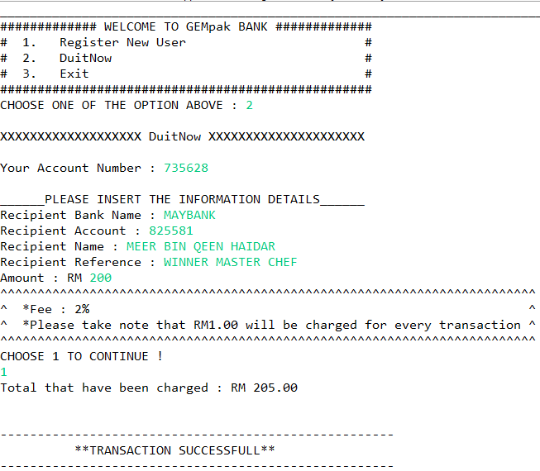

1. System will ask user if they want to make another transaction. If user choose ‘y’, the system will ask again for the details needed and will display it again. When user choose ‘n’, the system will return to the main menu again.

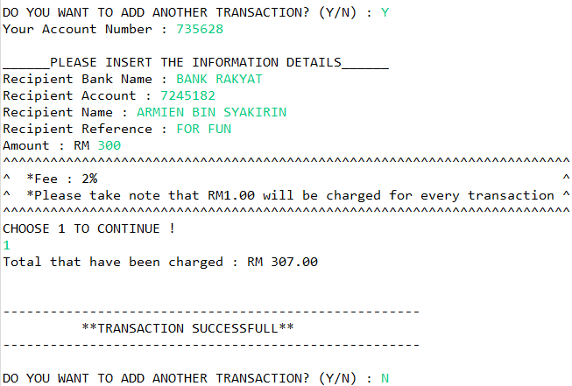

1. If user choose 3, user was decide to exit from the page. System will greeting user with thankyou for using our GEMpak BANK.

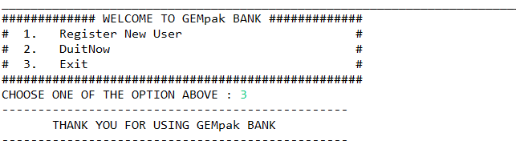

1. Our bank is lovely to giving some gift to our beloved customer since we are celebrating a new year. User need to choose their gift by pick the number of the list given. Before user decide to choose their gift, they need to play a guess number game (it is just for fun ). User need to guess a random number until it corrects. However, user just can attempt it for 5 times.

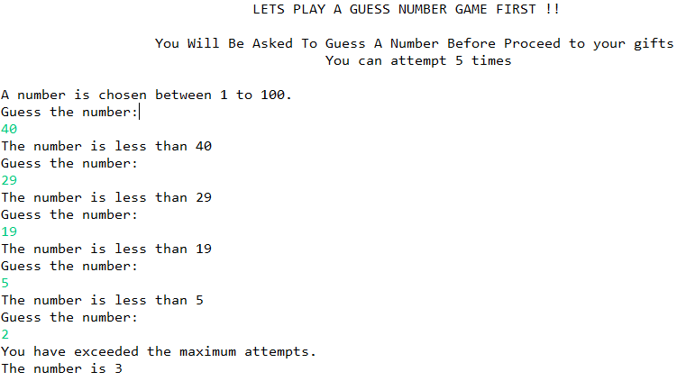

1. Lastly, after user finished the guess number game, user will provide the list of gifts that need to choose. If user choose gift 1, user will get notebook and calendar as a gift.

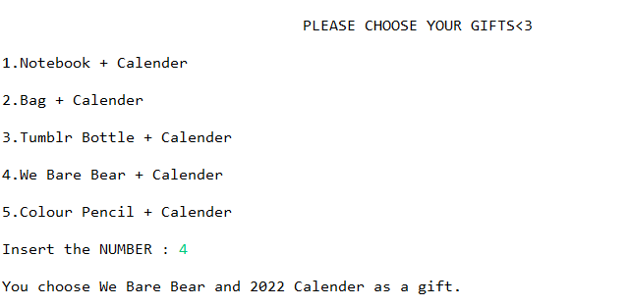

**Numerical Data and Expression**

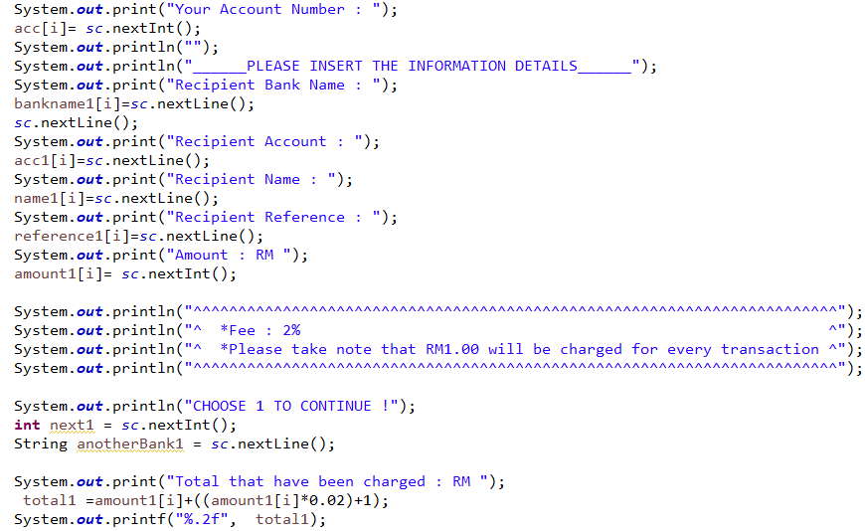**Selection Control Structure**

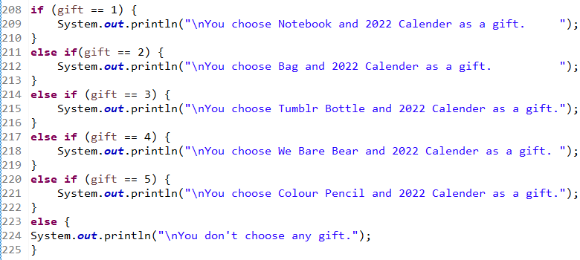

**Repetition Structure**

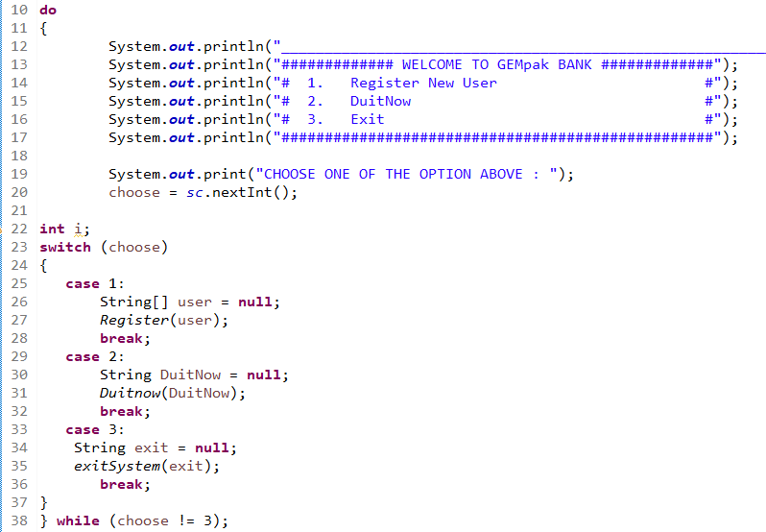

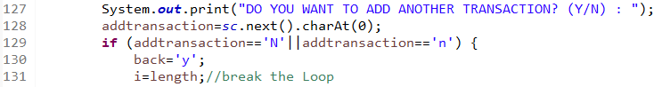

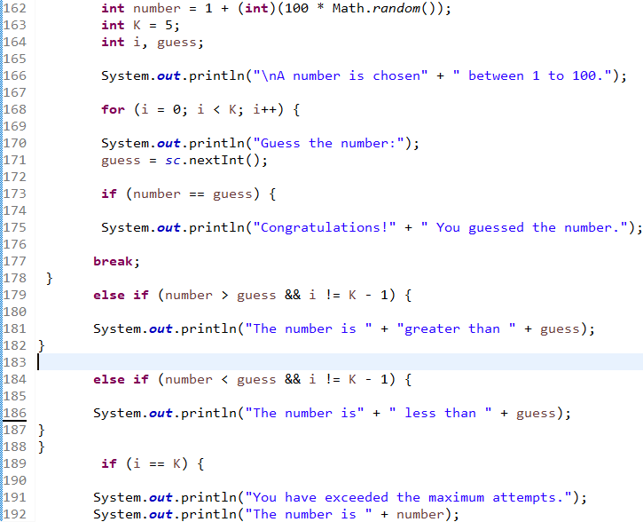

**Array**

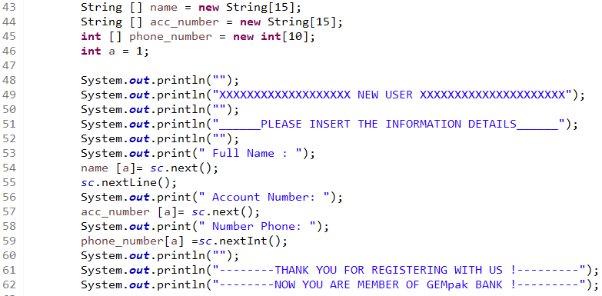

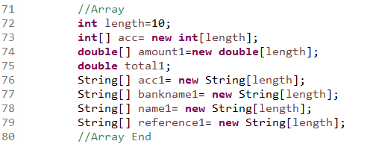

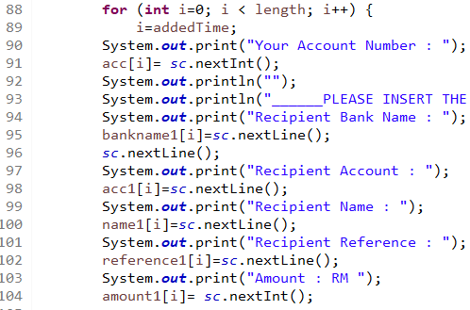

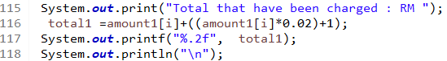

**Passing Array to Method**







**Method**

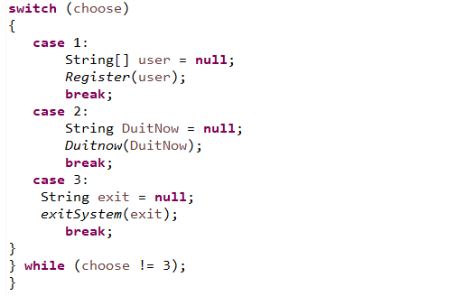

**2.4 Credit Card**

**Credit card:**

1. If you choose 3 you will enter credit card service. The system will show a menu for credit card service. 1 for payment using credit card, 2 for gift shop, 3 for credit card calculator and 4 for exit credit card uses.

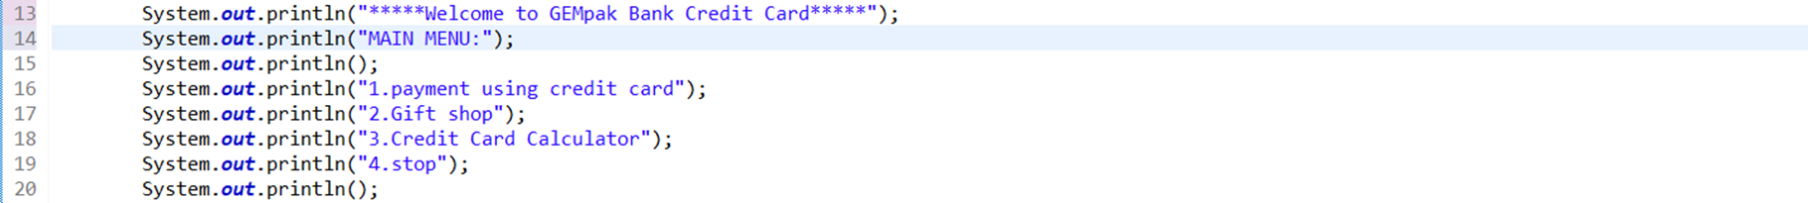

2. If the user chooses 1, the user will be sent to payment using a credit card. In this service users need to enter how much the price for an item that is listed in this system. For example, smartphone, laptop, petrol and more. You can give RM 0 if you don't want to buy any of this stuff.

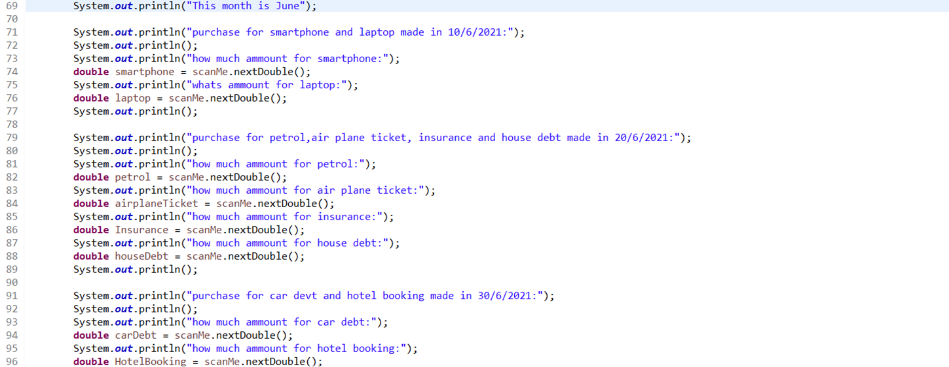

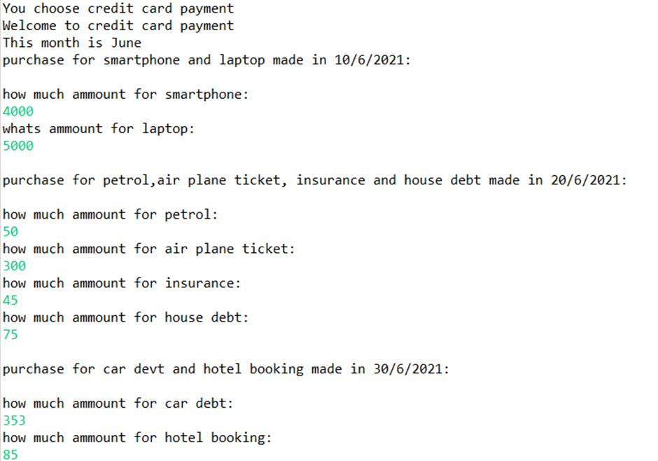

3. After that, the system required you to choose a credit card to use to pay for things you are buying. There are 3 credit cards you can use. First one is GEMpak e Credit Card. Second one is GEMpak Petronas Platinum MasterCard with 7% cashback. Last one is GEMpak Platinum Explore Credit Card-I with 5% cashback. Afterwards the system will calculate how many balances are in this credit card and your cashback (if have).

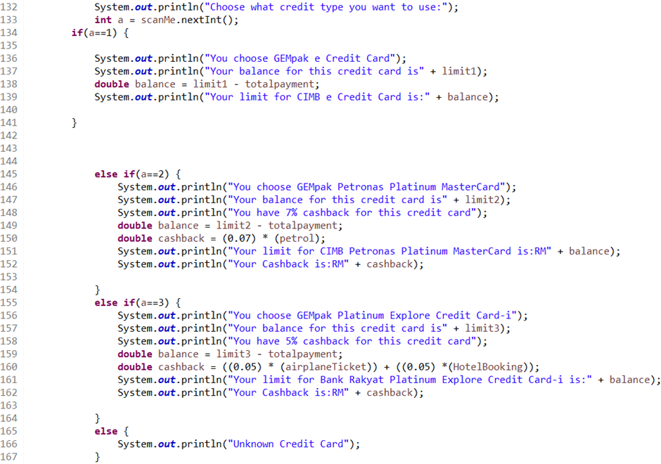

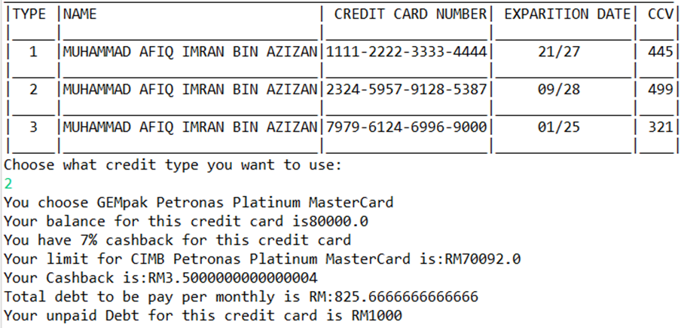

4. After that the system will calculate charge payment for this month and money left.

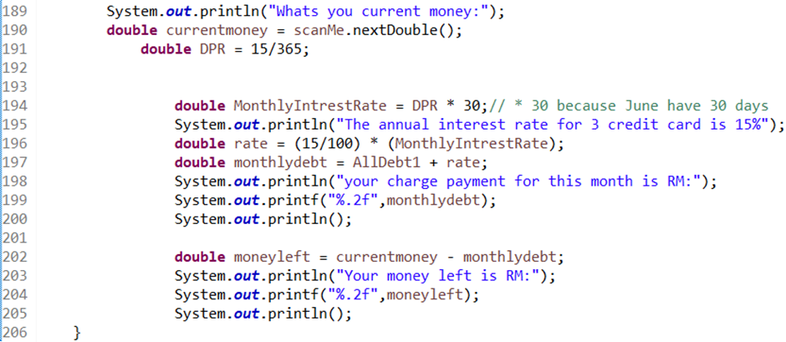

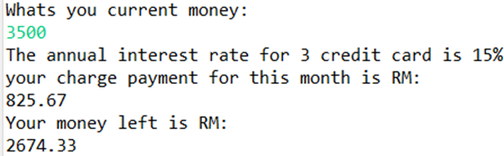

5. If you choose 2 the system will put you in a gift shop. Here you can choose 3 items based on points that have been given. Currently you have 30 points. The item is as follows.

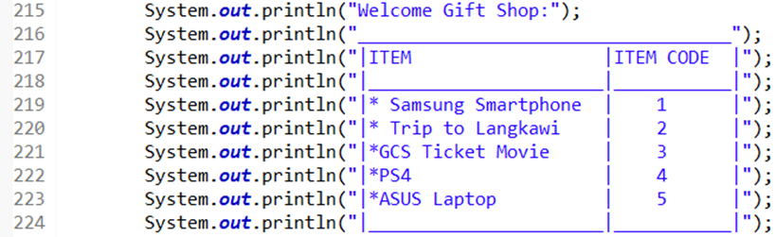

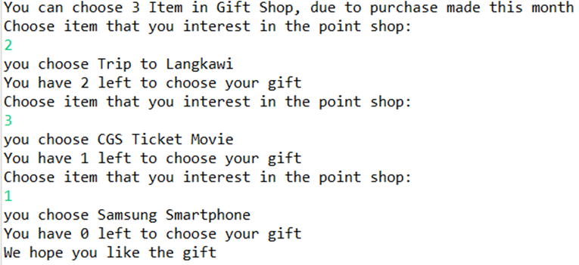

6. This last one is a calculator for payment in 1 month. And first of all you need to enter how many probability you want to see in this calculation.



7. After that the user needs to enter the investment for the credit card, its annual interest rate and payment you want to make for the credit card. The system will calculate interest and after that the interest will be added to investment and become a paid amount. Lastly, the balance will be achieved by paid amount minus payment.

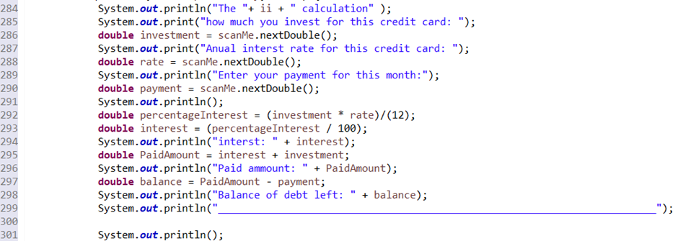

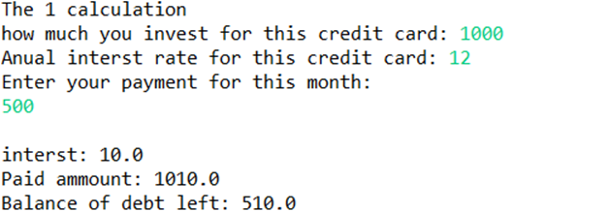

8. Lastly, when you choose 4, the system will exit the credit card menu and to the main menu. The system will print out “thank you for using our program”.

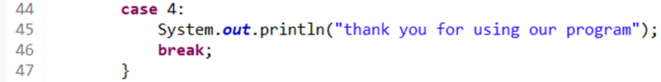

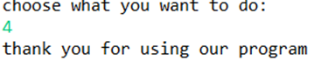

**Numerical Data and Expression:**

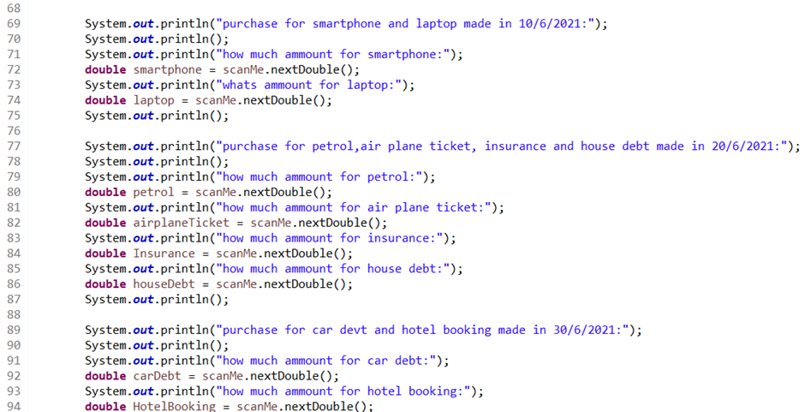

**Selection Control Structures**

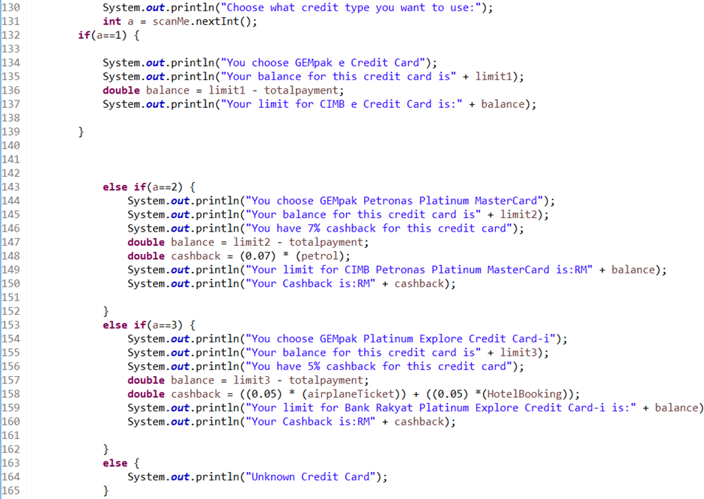

**Repetition Structure**

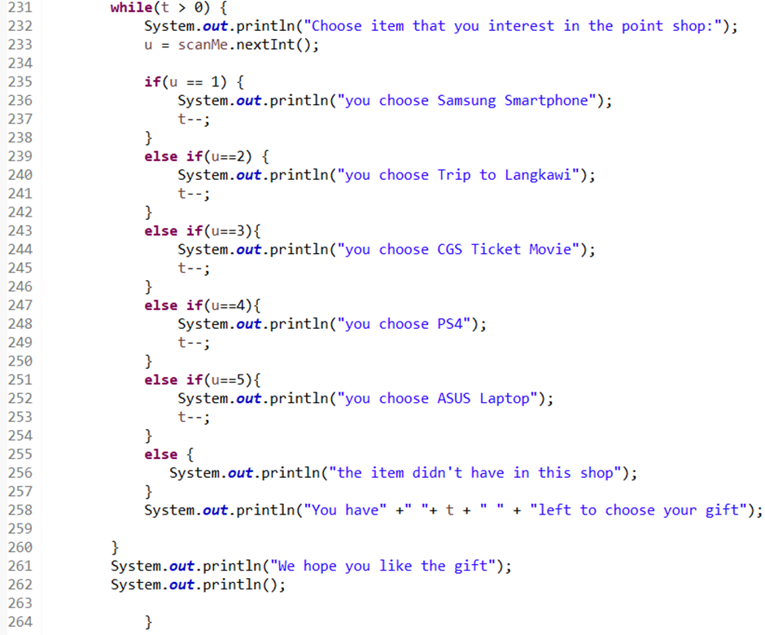

**Array**

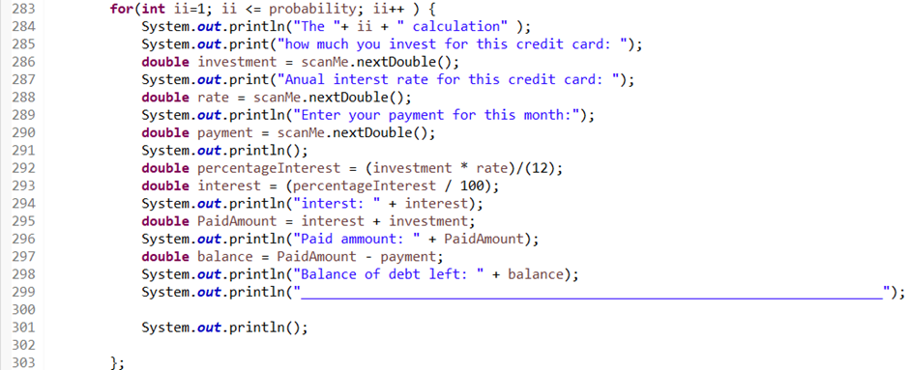

**Passing Array to Methods**

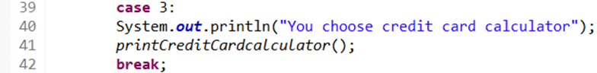

**Using Methods**

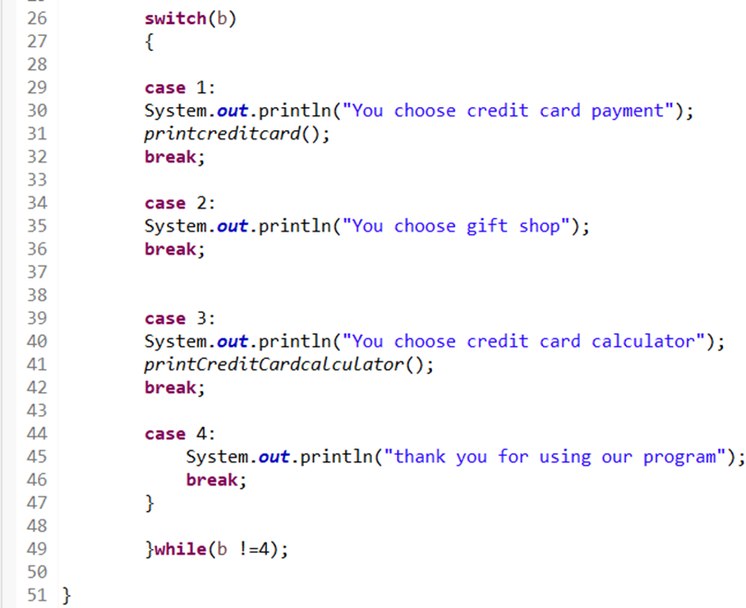

**2.5 Housing loan**

When you enter the system, first thing will come out is a menu, the system will list all menu which is register in the system, loan calculator, type house, E-Statement and exit the system.

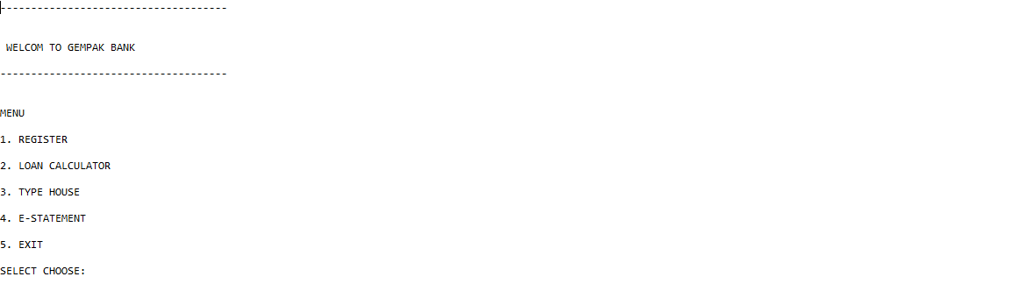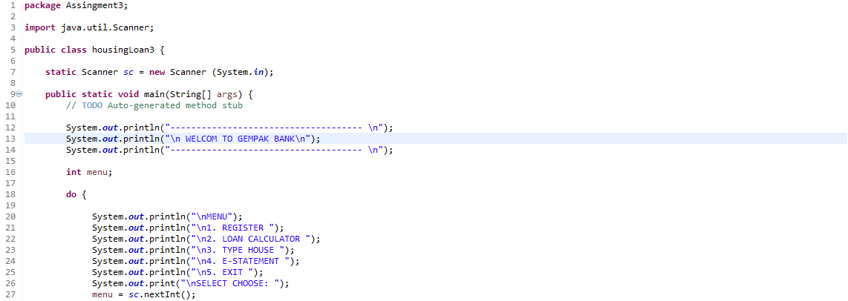

Next, when the user chooses number one the system comes out with the part that the user needs to register the full name, phone number and the account number in the system.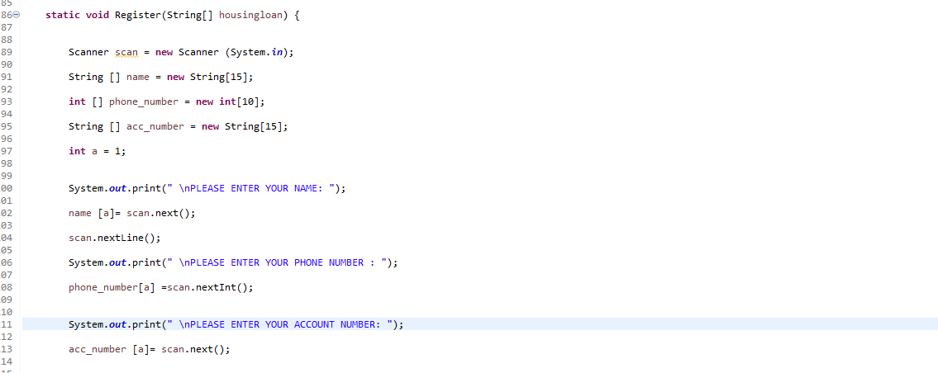

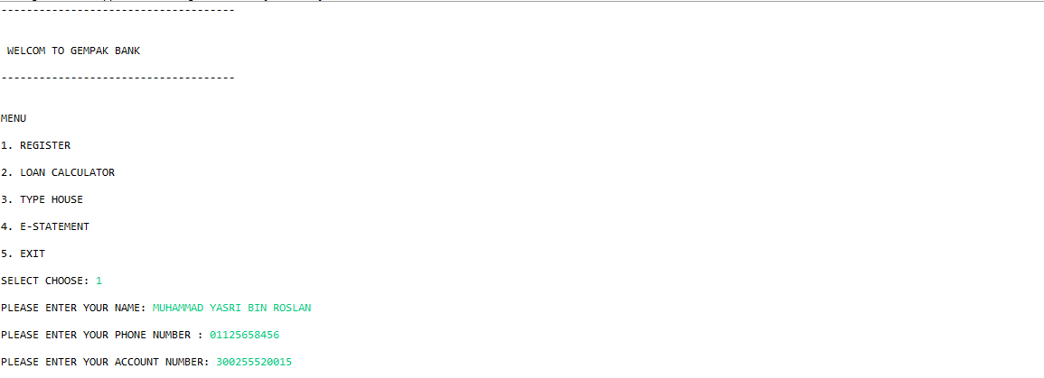

After the user registers the menu will come out again and ask the user to choose what they want as the next step. If the user chooses number 2 the system will come with the loan calculator. At this part the user can calculate the budget of monthly payment and the total of the payment.

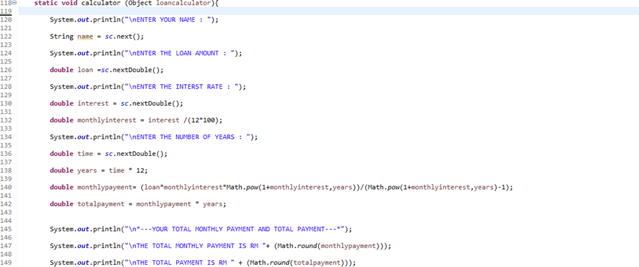

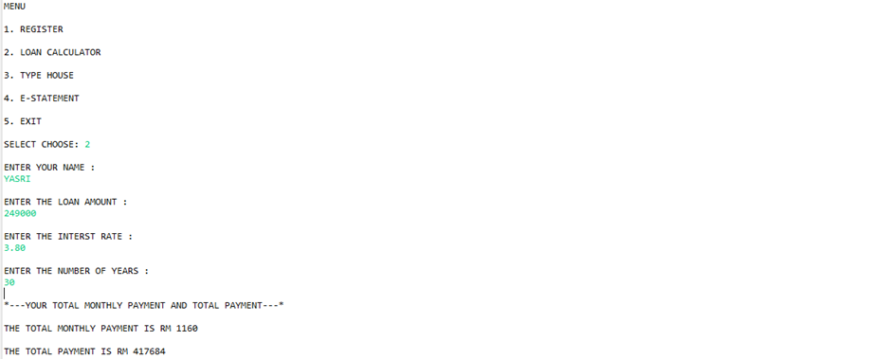

When the user wants to see the home package that GEMpak BANK suggests. Users can enter number 3. The system will ask the user how much budget that they want to house. After the user enters the budget system will give the suggestion Houser according to the budget. At this part the system will ask the user if they are interested in the suggestion and if user interested user needs to enter the number of packages and automatically the system will calculate the monthly payment of the home package.

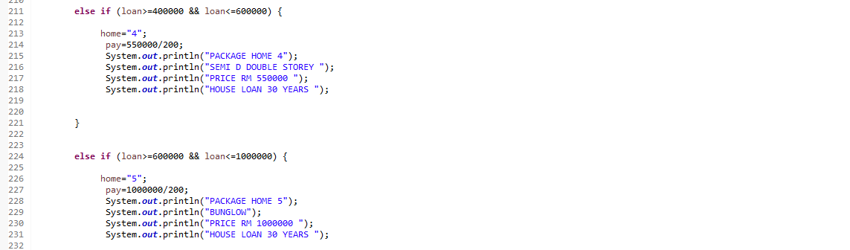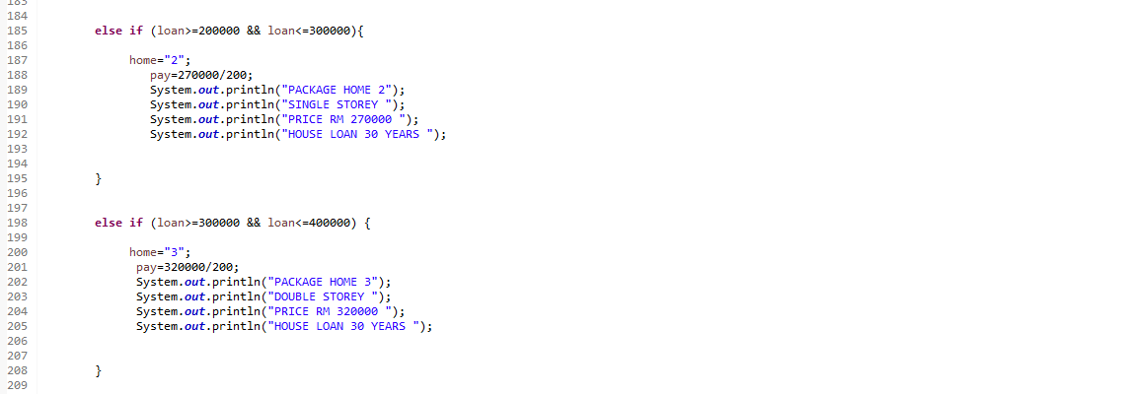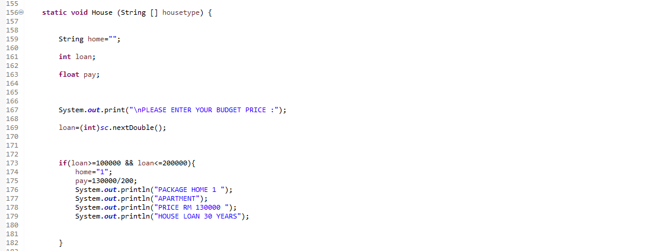

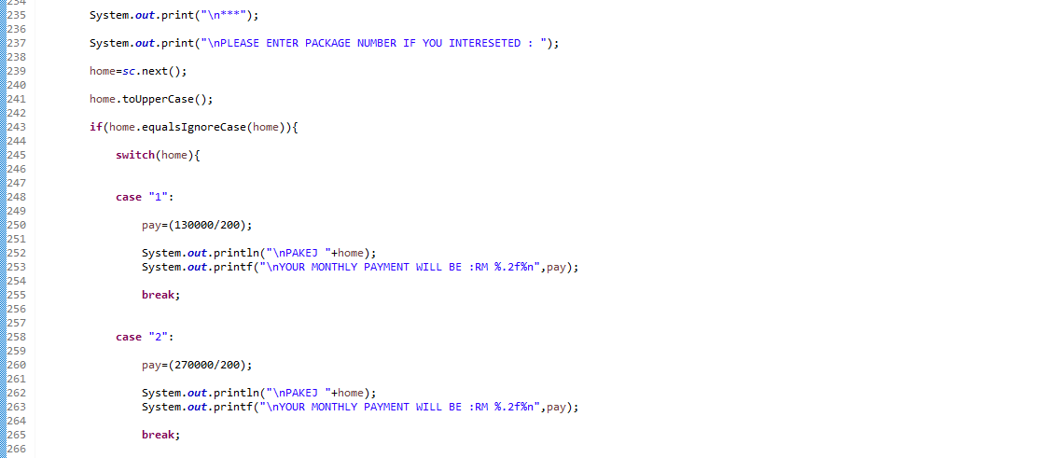

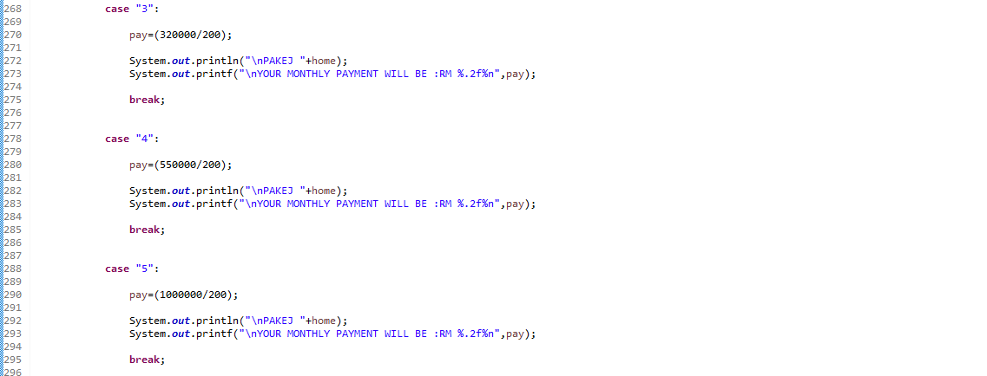



After that, in the system user can calculate the total of loan according the how many numbers of years they borrow at the bank.

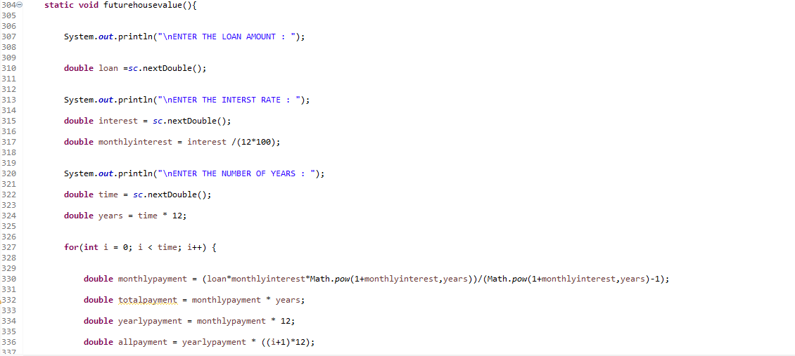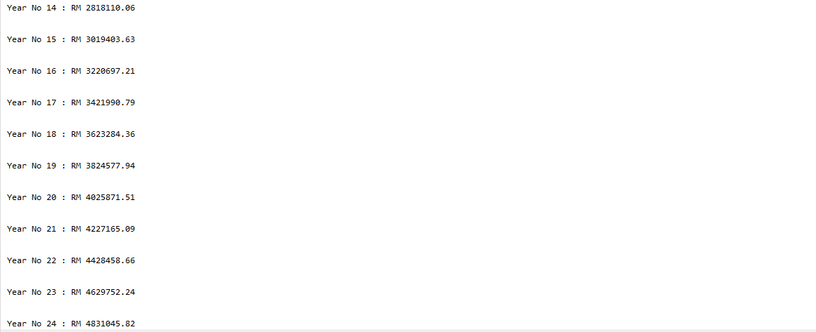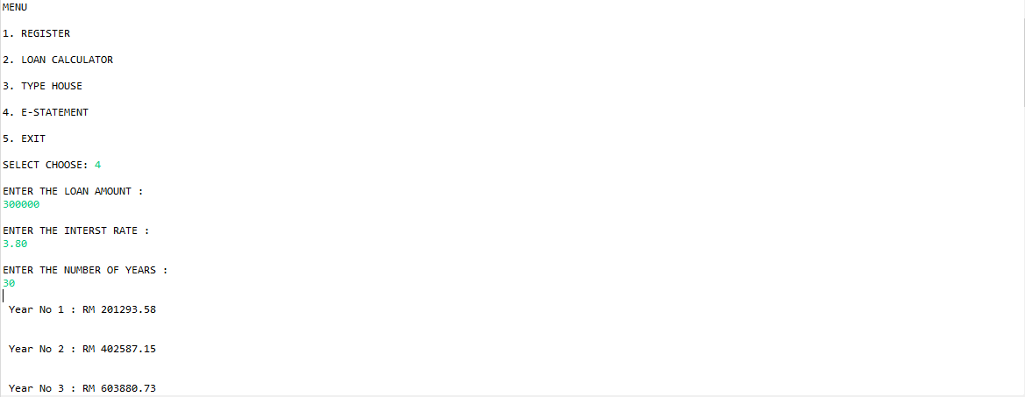



Lastly, the user can choose to exit the system by entering the number 5.

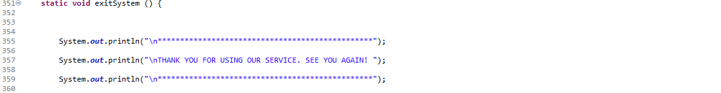

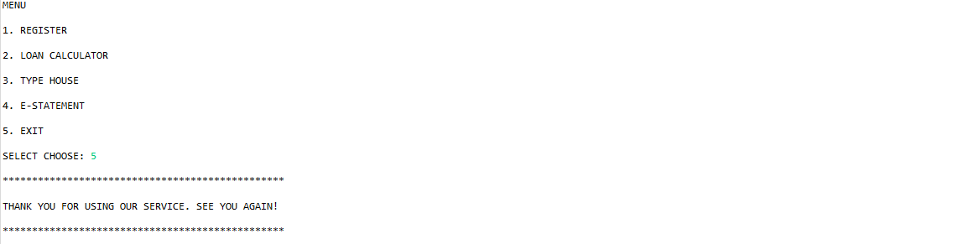

**Numerical Data and Expression:**

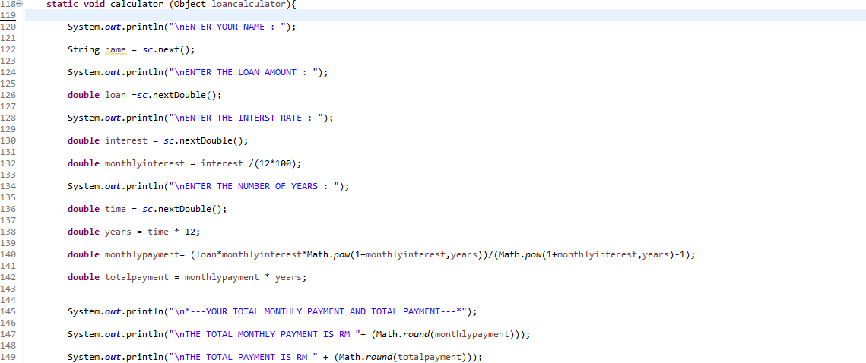

**Selection Control Structures**

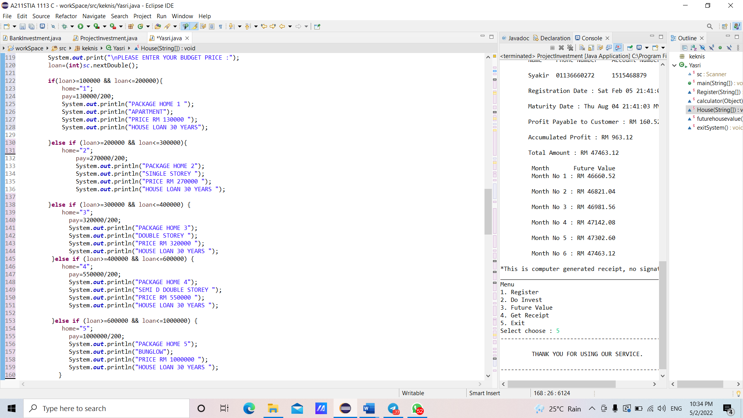

**Repetition Structure**

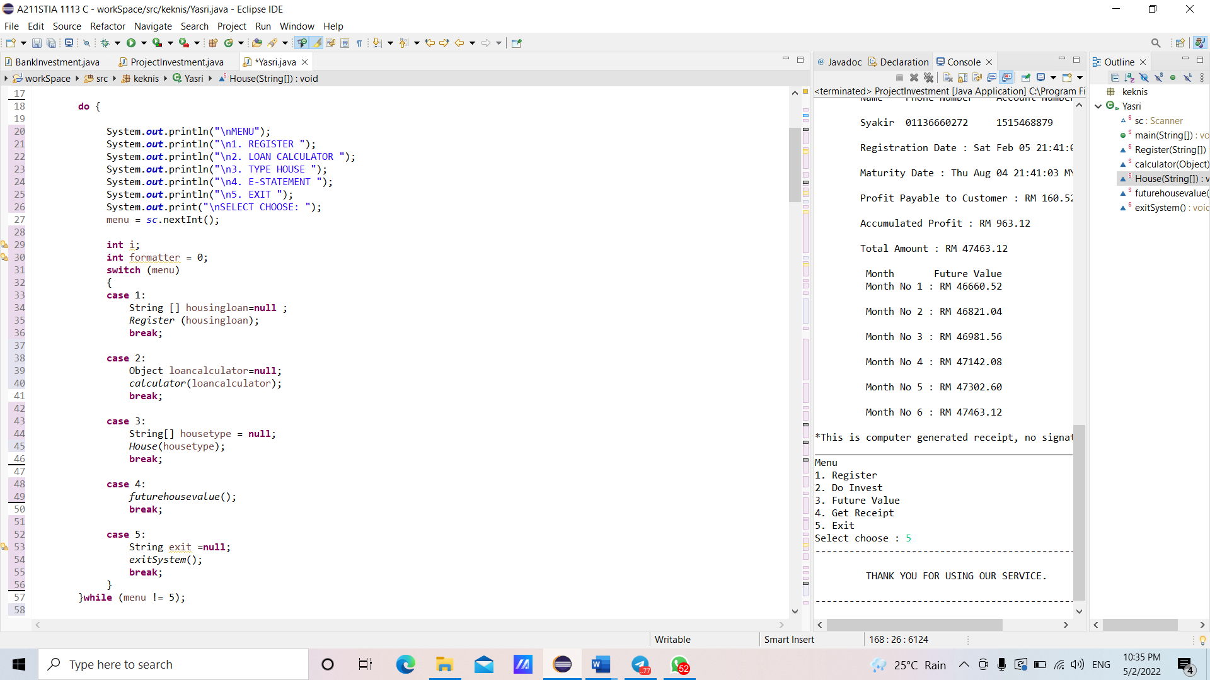

**Array**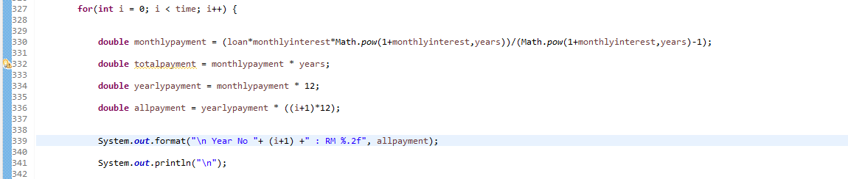

**Passing Array to Methods**

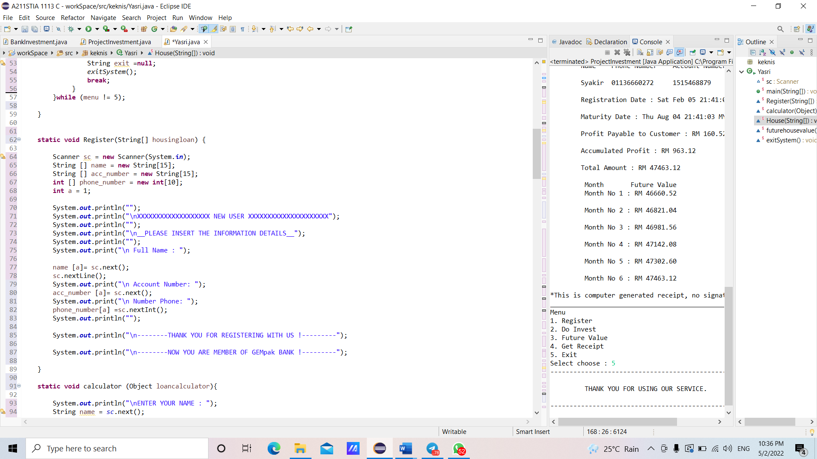

**Using Methods**

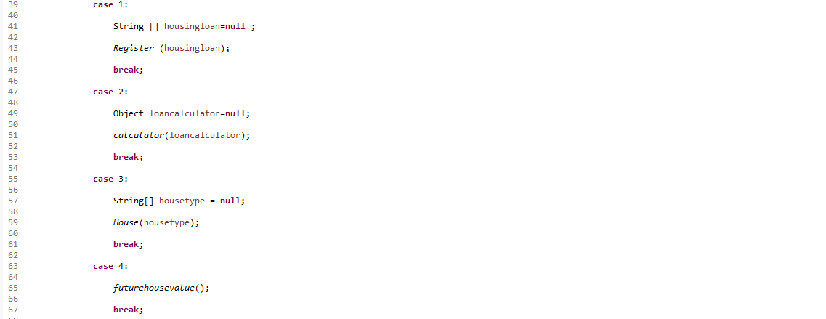

**2.6 Investment**

Customers will automatically be in investment section when they choose number 5 as their selection from the menu. After that, the system will list out the menu for investment which means the customer have to do all the list given one by one if they want to know about the calculation for term-investment. After get enter for investment section, the customer needs to choose 1 and then need to fill the information likes name, phone number, and account number.

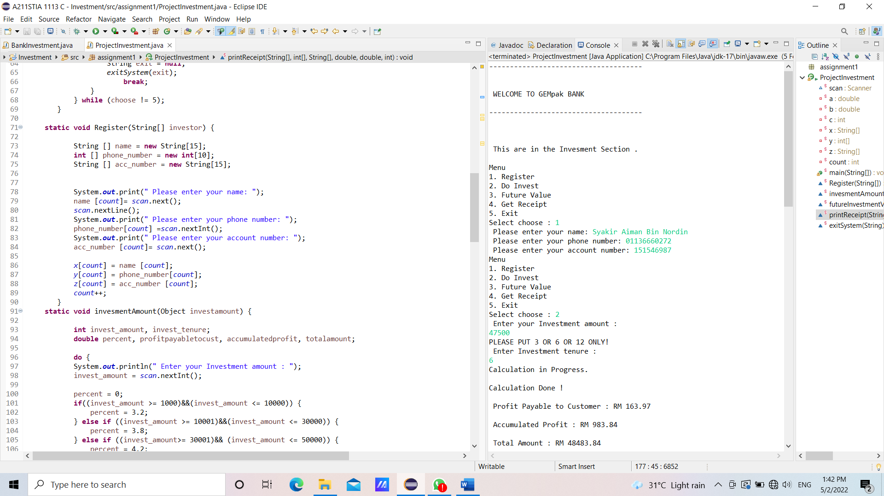

Then, the system will list the menu again. So, customer have to choose 2 to do investment. After that, customer needs to fill in the investment amount and investment tenure. Investment amount should be put between Rm1000 to Rm 50000. If they put others values, so the system will show the message, which is “PLEASE PUT AMOUNT BETWEEN RM1000 TO RM50000”. If not, the system will be said “Please Follow Instruction!”. For investment tenure, system will ask the customer to put the investment tenure only for 3,6 and 12. For every investment tenure, it has been different percentage net to customer which is for 3 months is 3.2%, 6 months is 3.8% and for 12 months is 4.2%. Then, system will calculate profit payable to customers, accumulated profit and total amount.

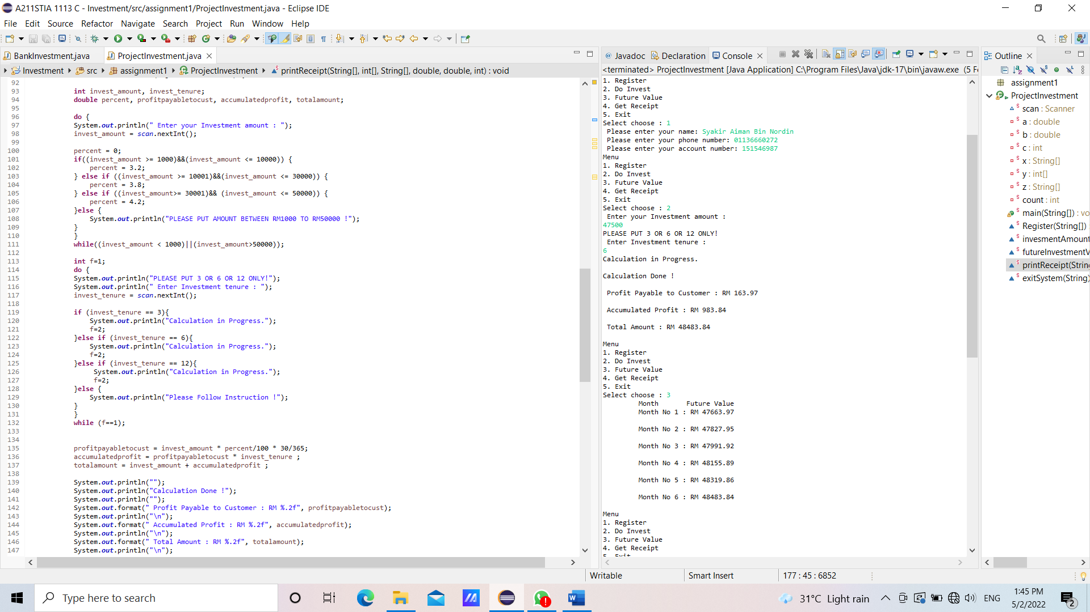

After that, it will show the menu again. So, if customer want to see the future value for the investment by month, choose 3. Then, system will list the amount by month.

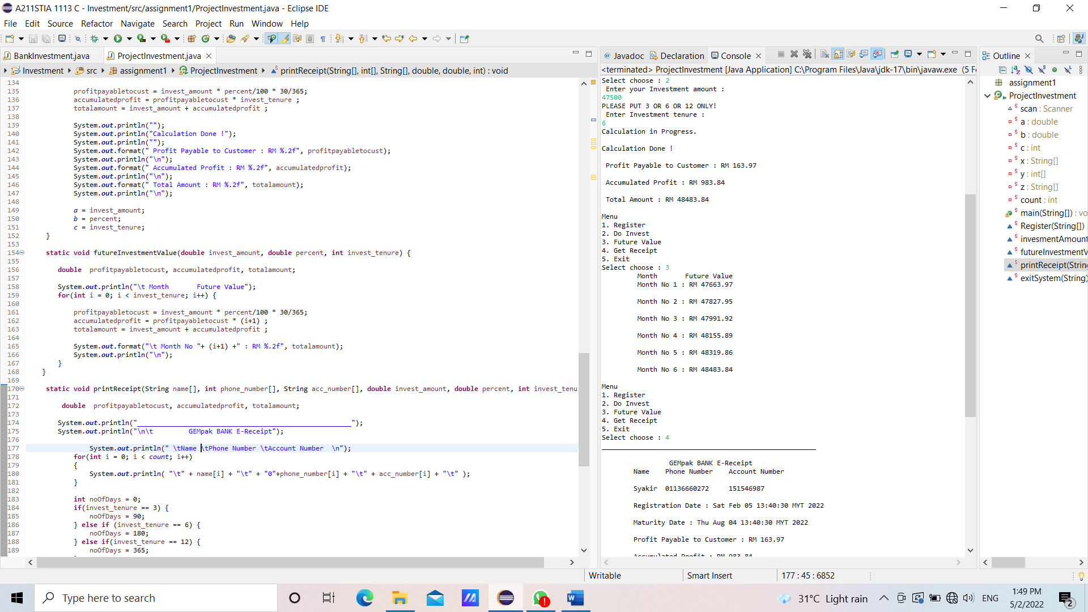

Next, if customer want to print receipt, choose 4. Then, system will show the customer’s name, phone numbers, account numbers, date of registration, date of maturity, profit payable to customer, accumulated profit, total amount and future values.

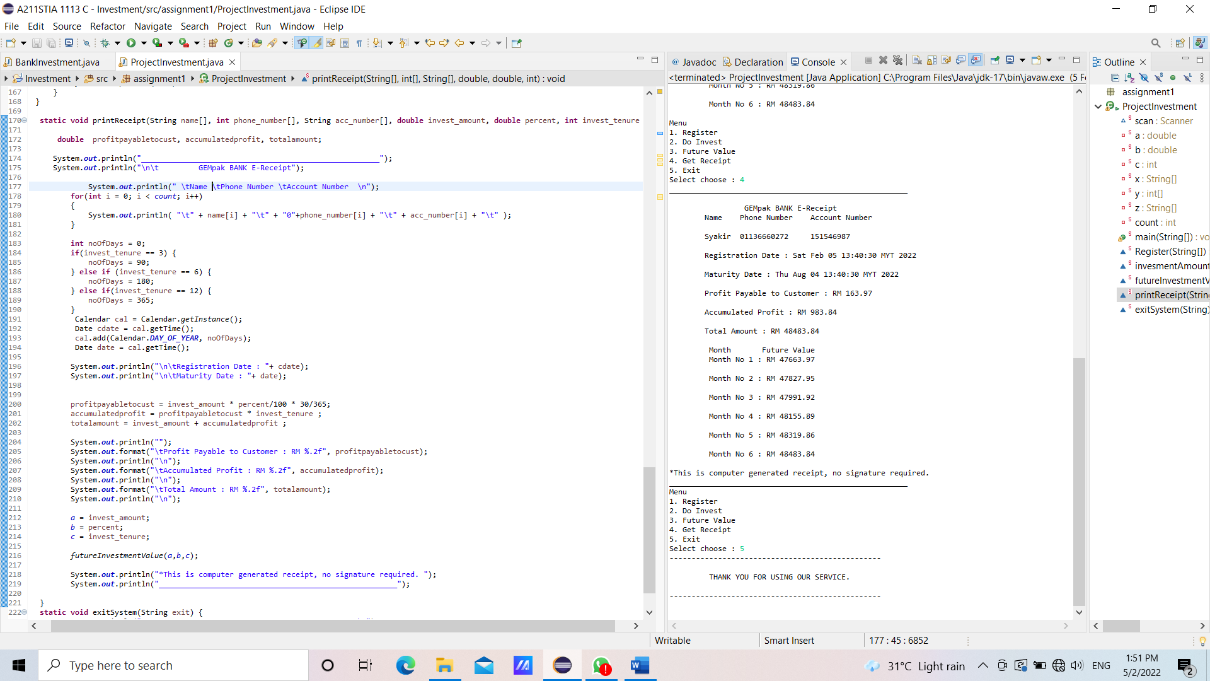

Lastly, customer can exit the system by choosing 5. Then, we will print thank you for choosing our service.

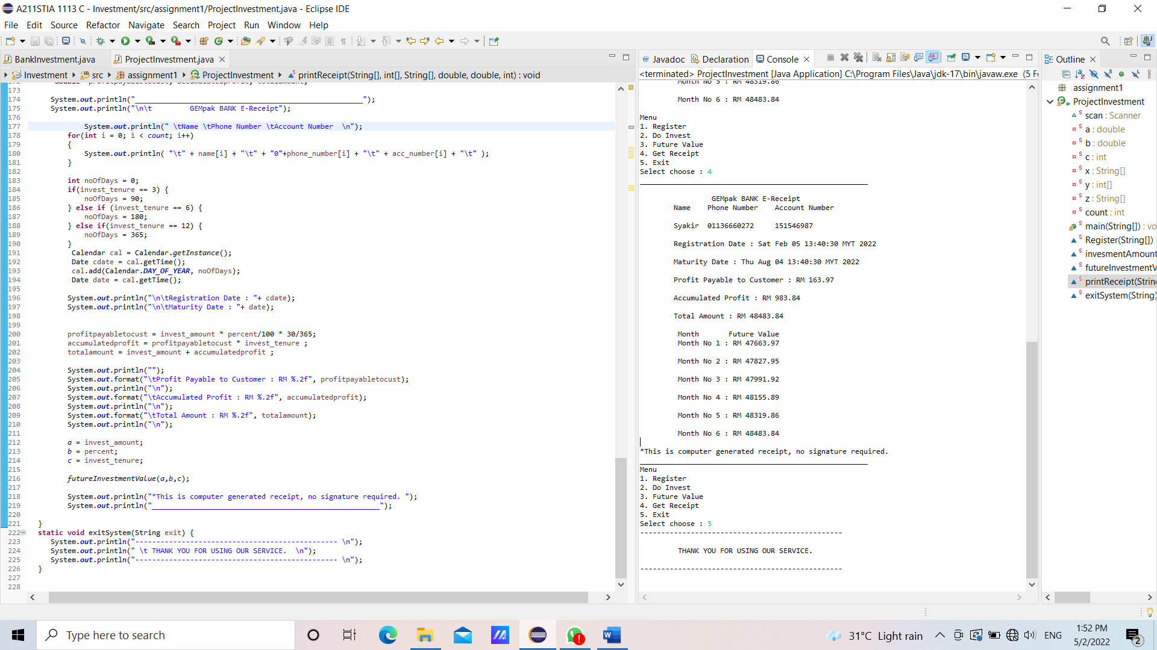

**Numerical Data and Expression (Investment)**

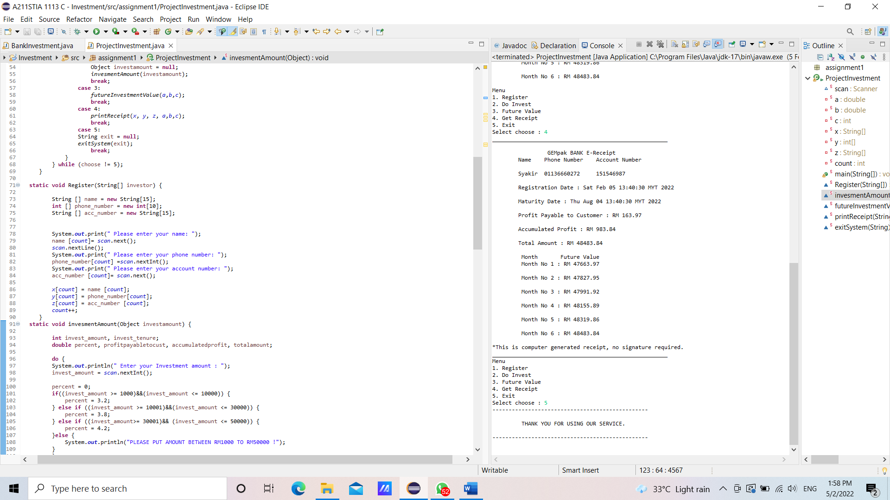

**Selection Control Structures**

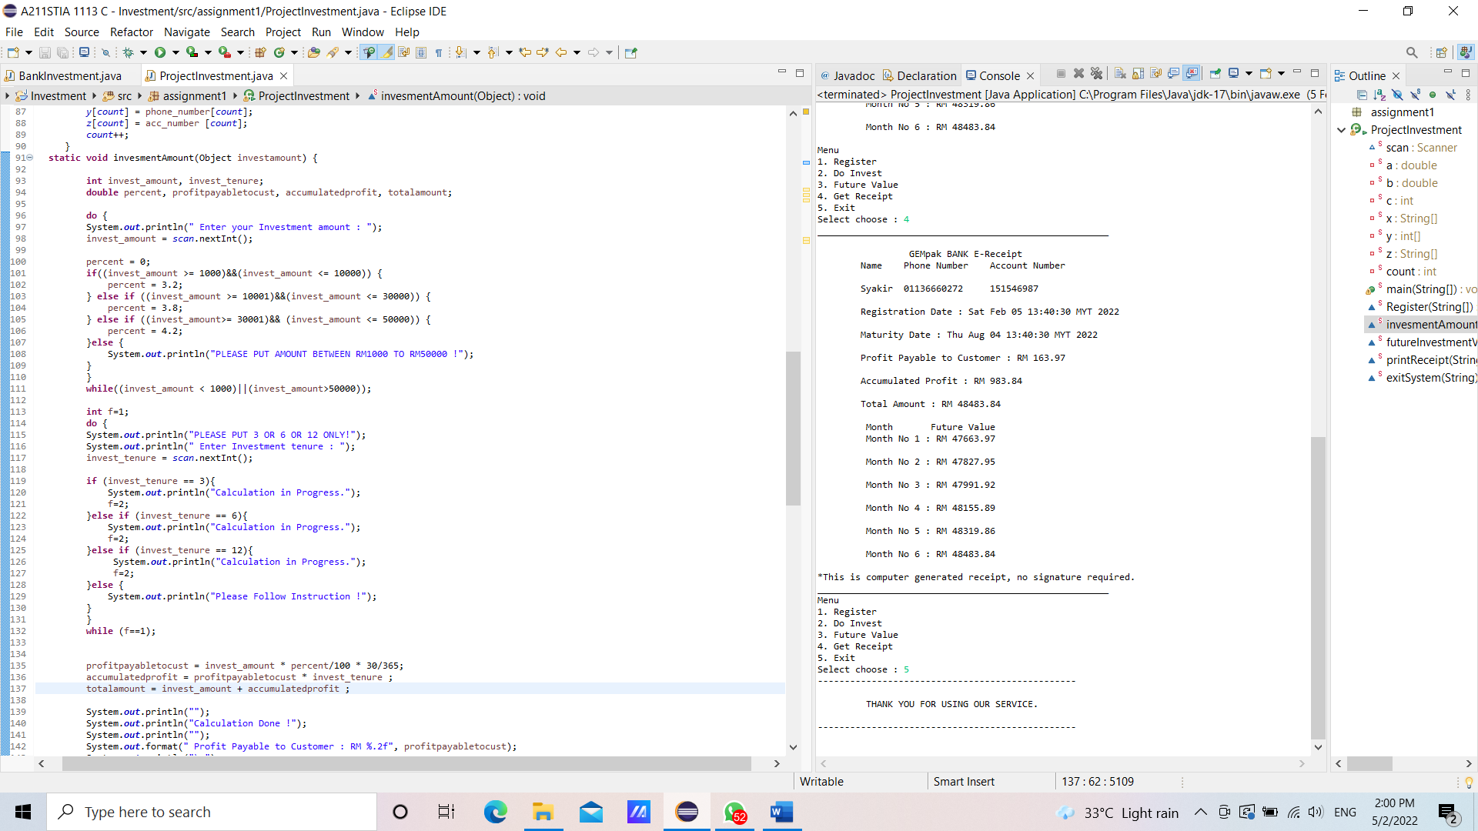

**Repetition Structures**

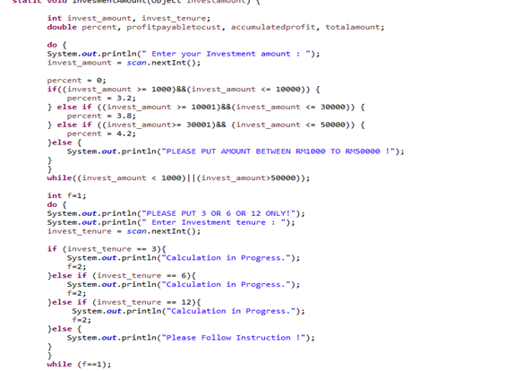

**Array**

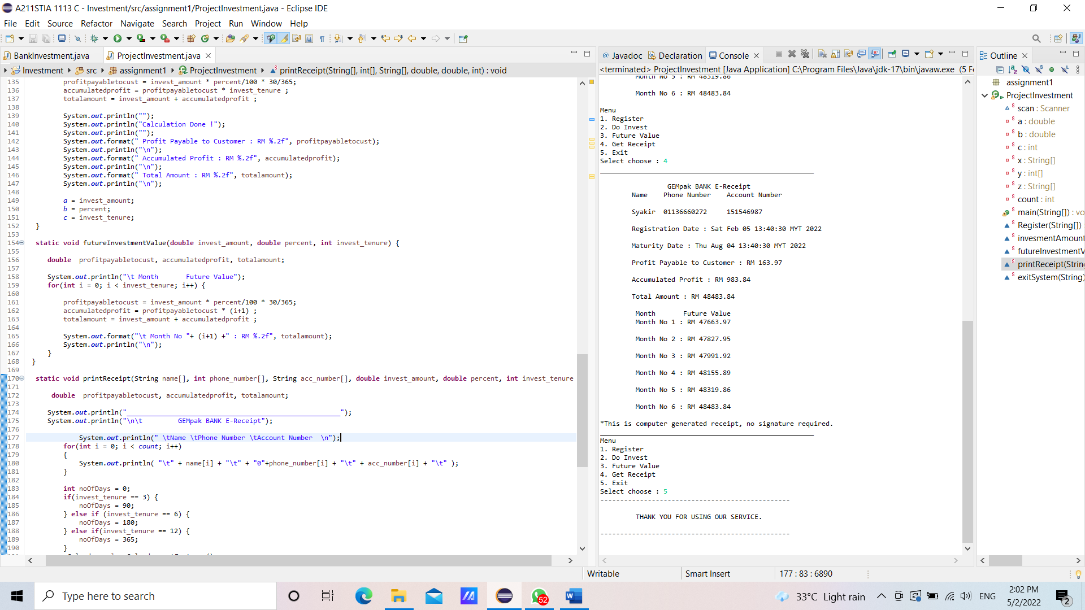

**Passing Array to Method**

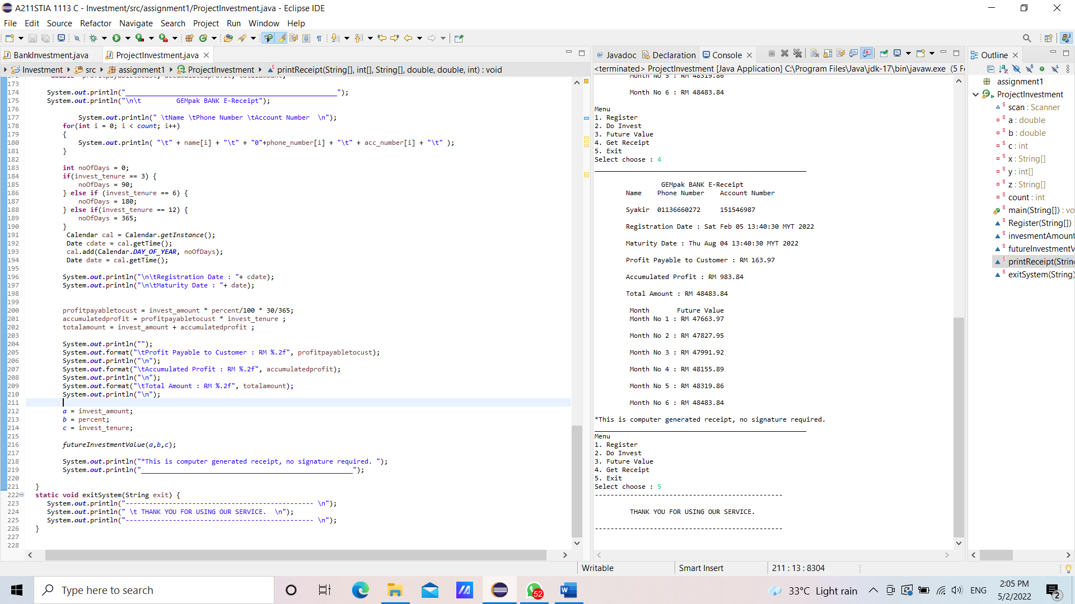

**Using Method**

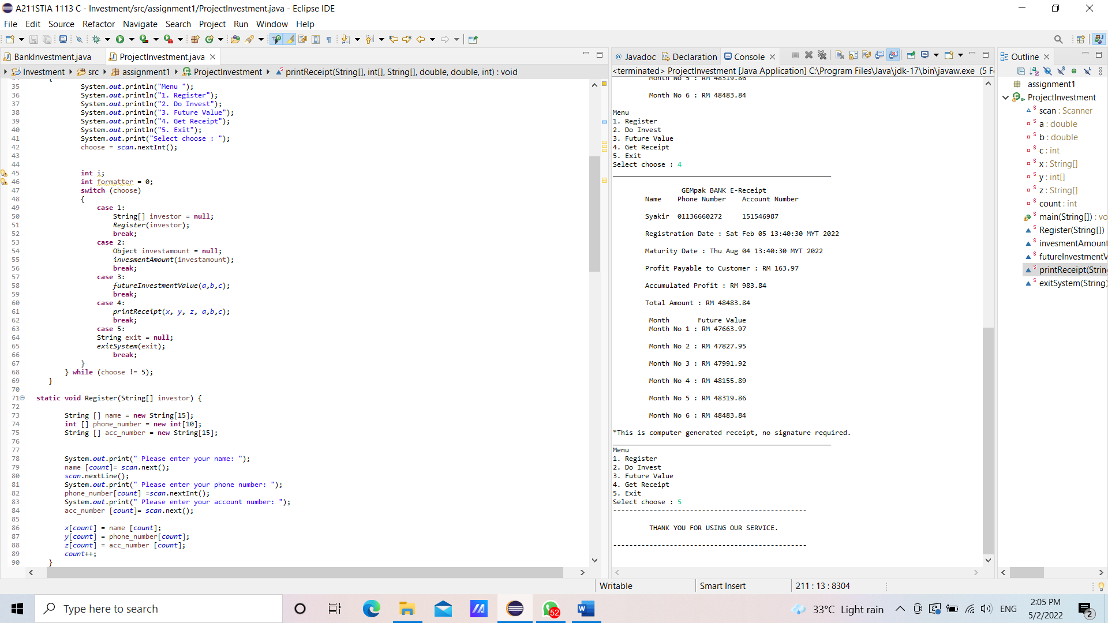

**3.0 Code**

**3.1 Main menu**

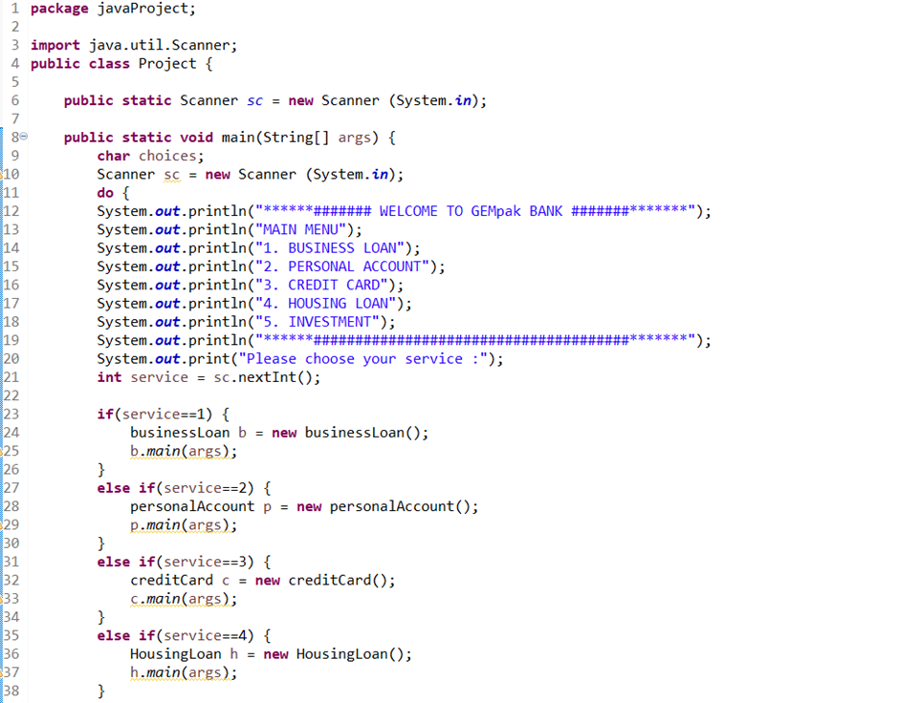

**3.2 Business loan**

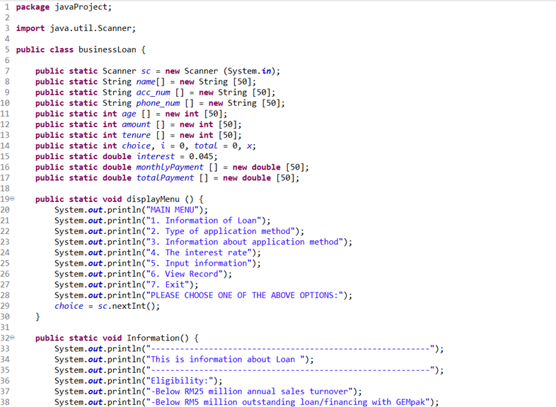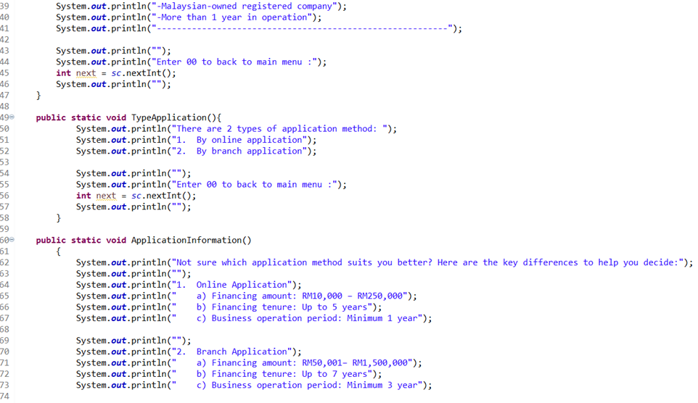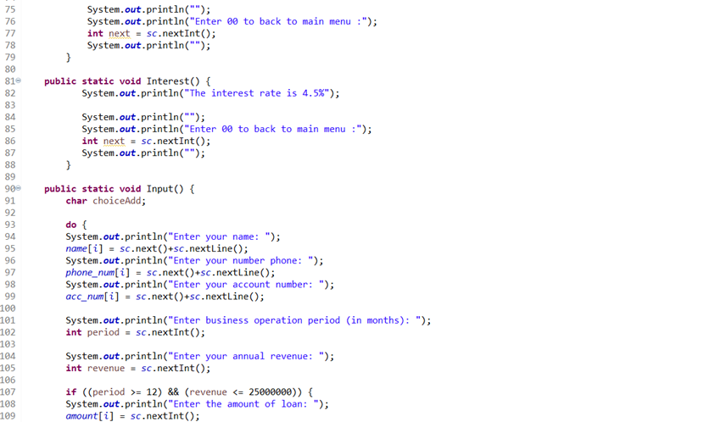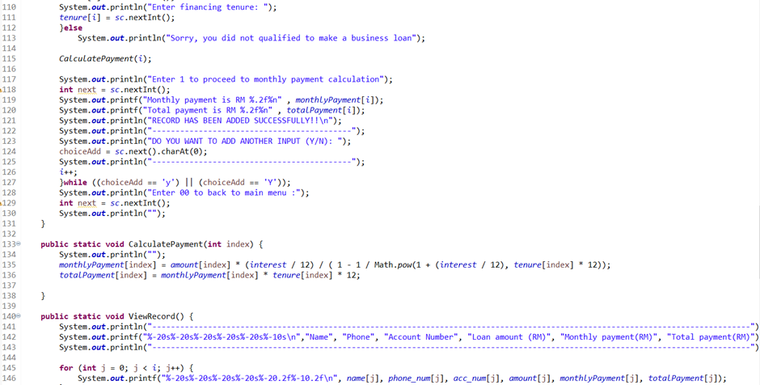

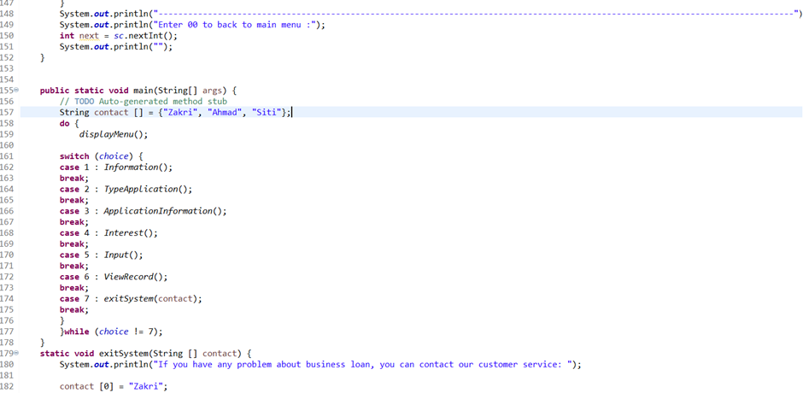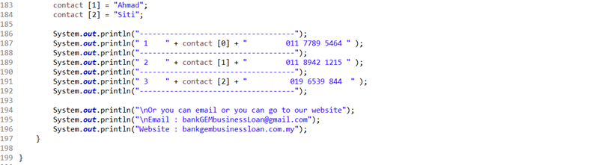

**3.3 Personal account**

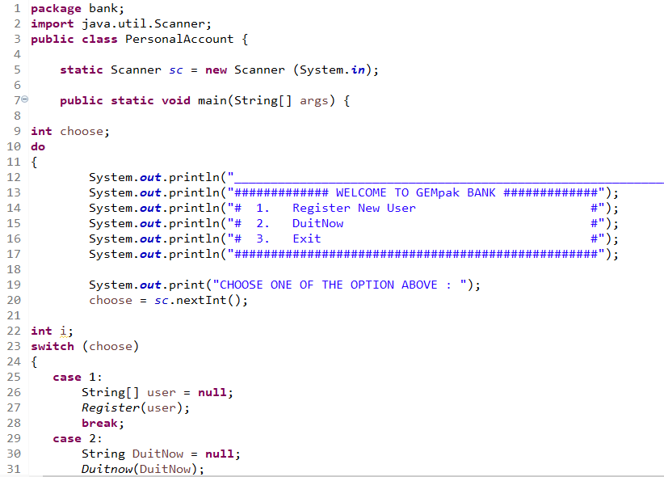

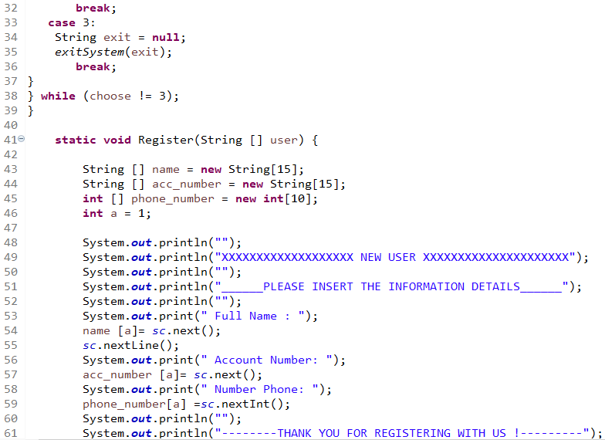

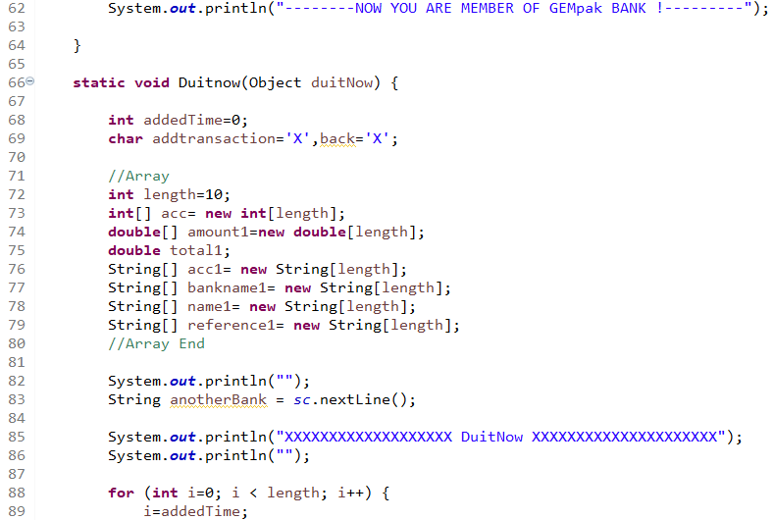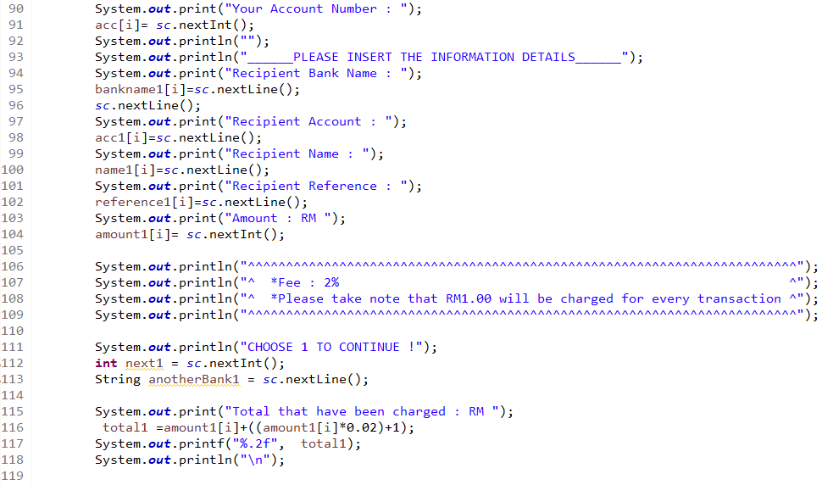

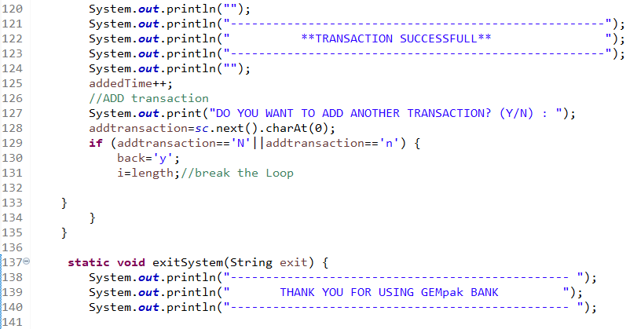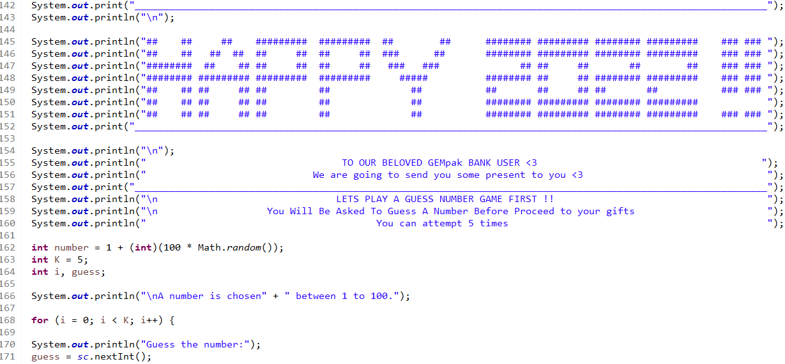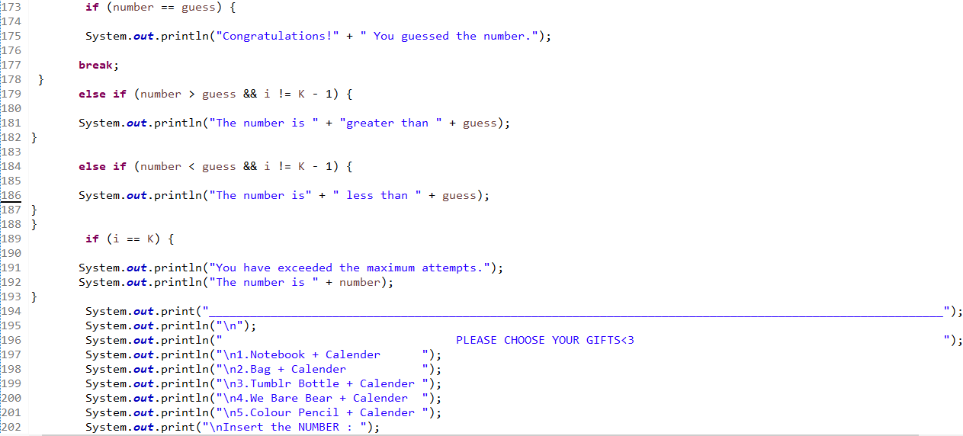

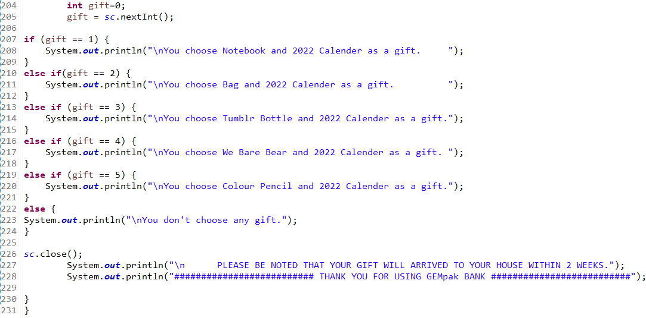

**3.4 Credit card**

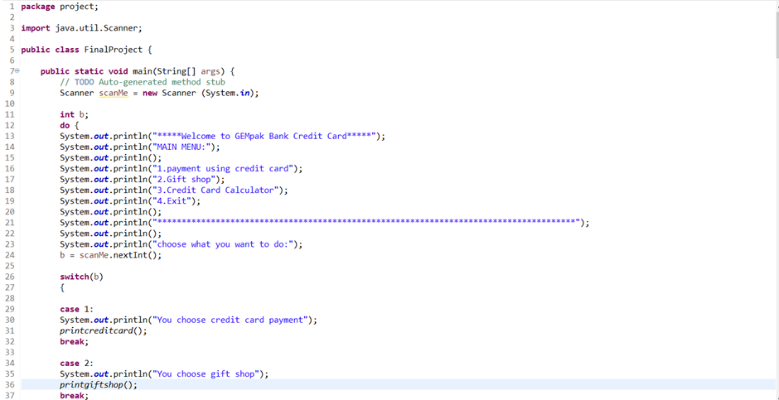

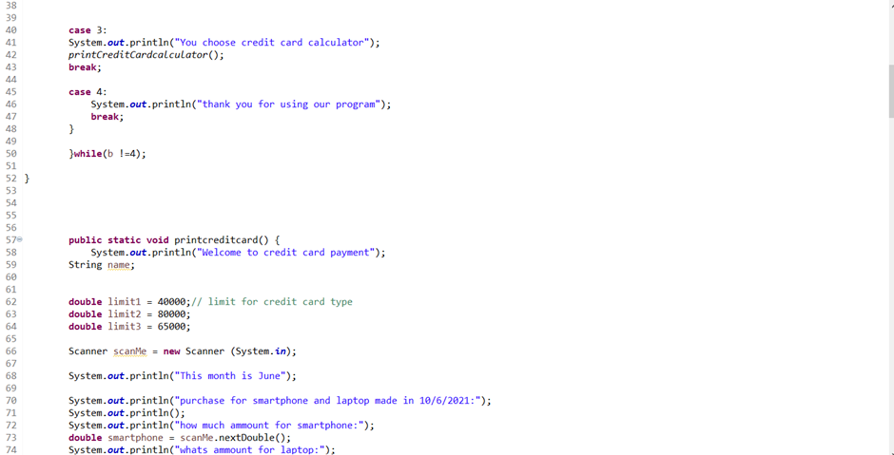

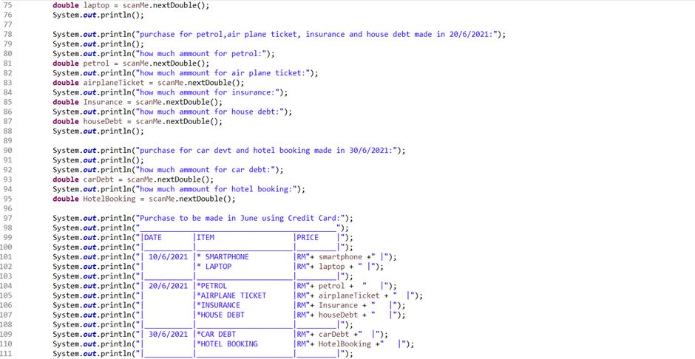

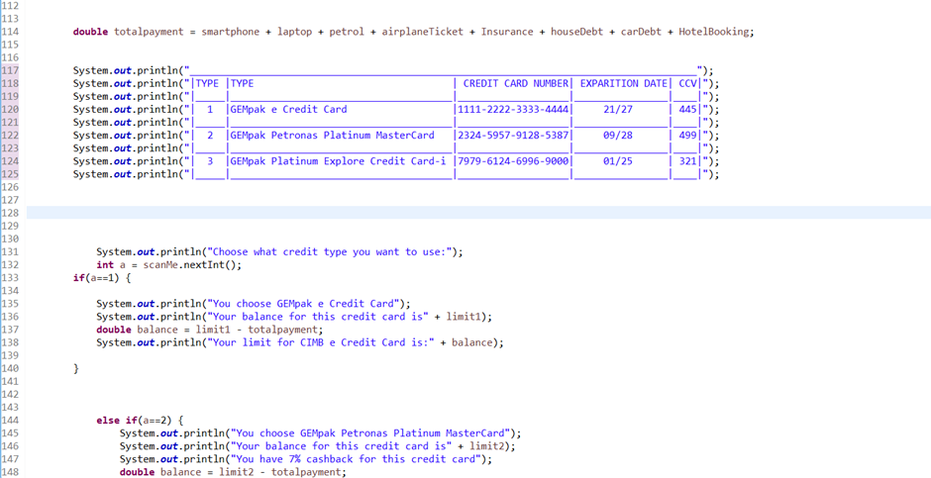

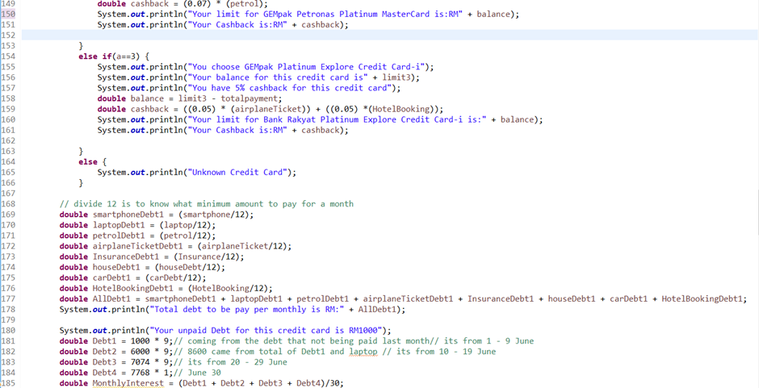

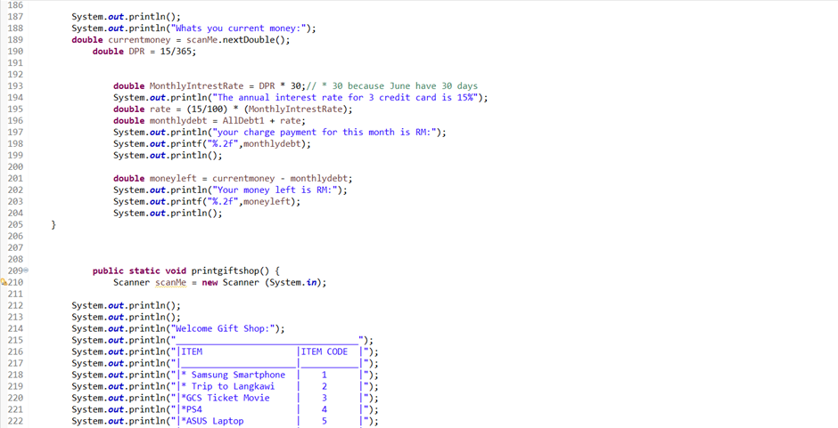

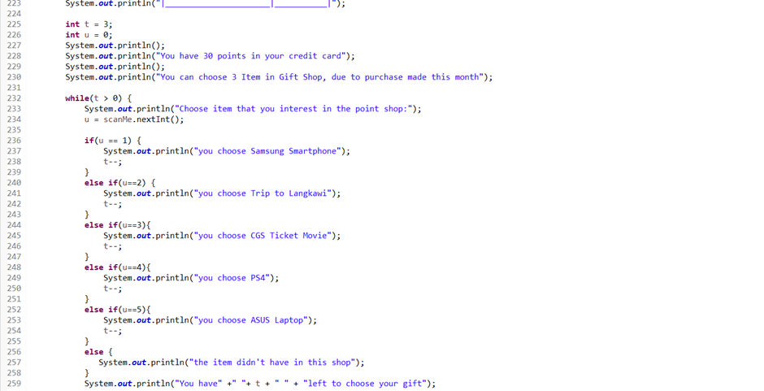

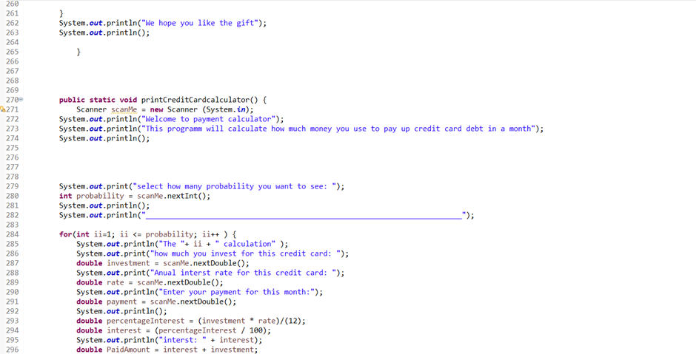

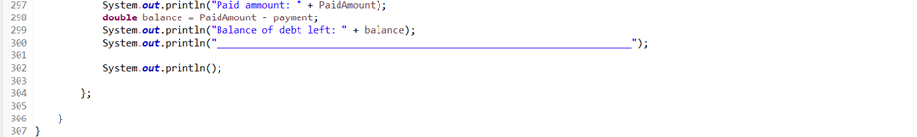

**3.5 Housing loan**

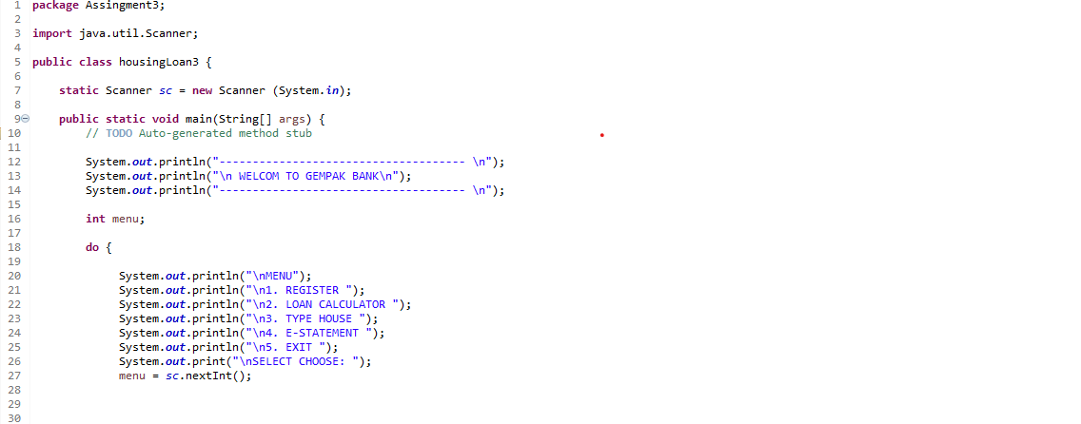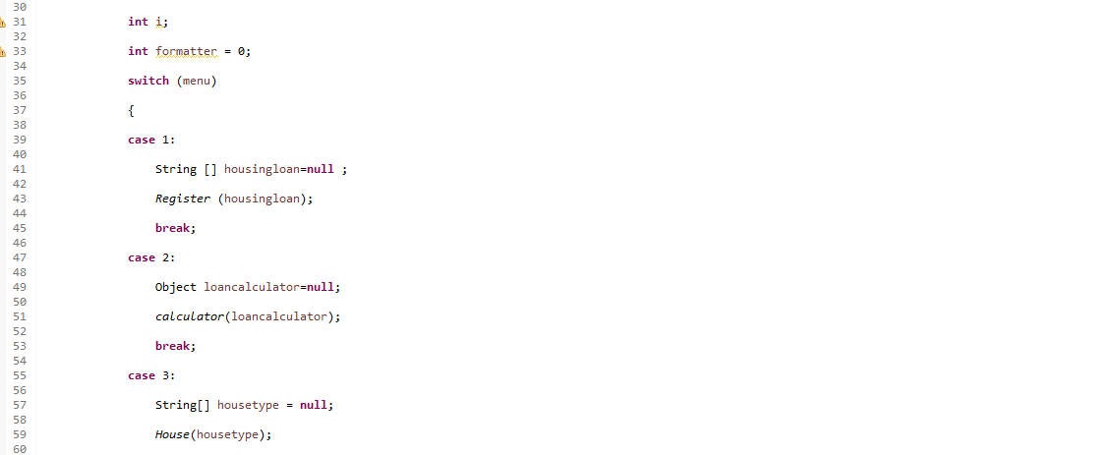

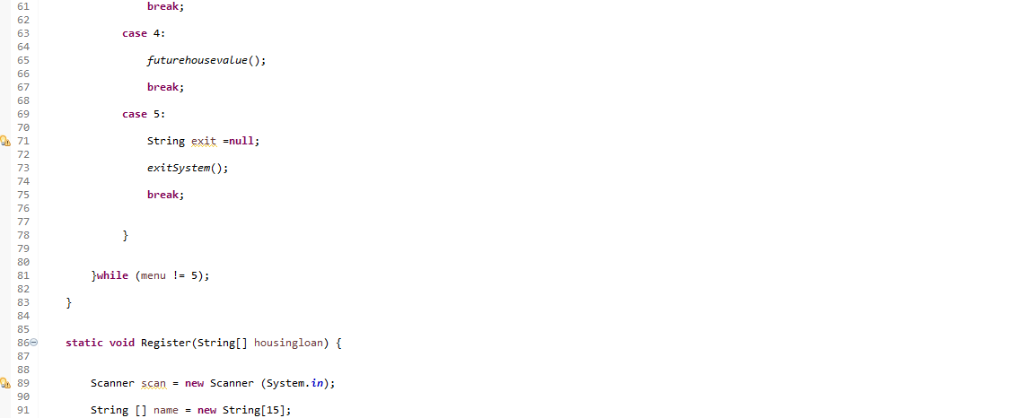

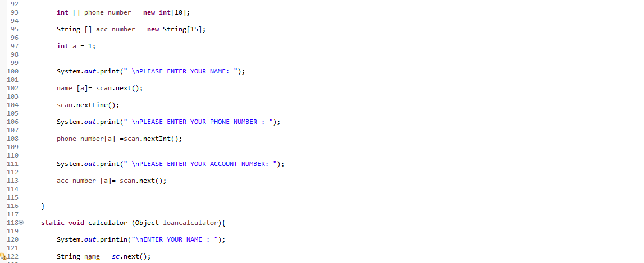

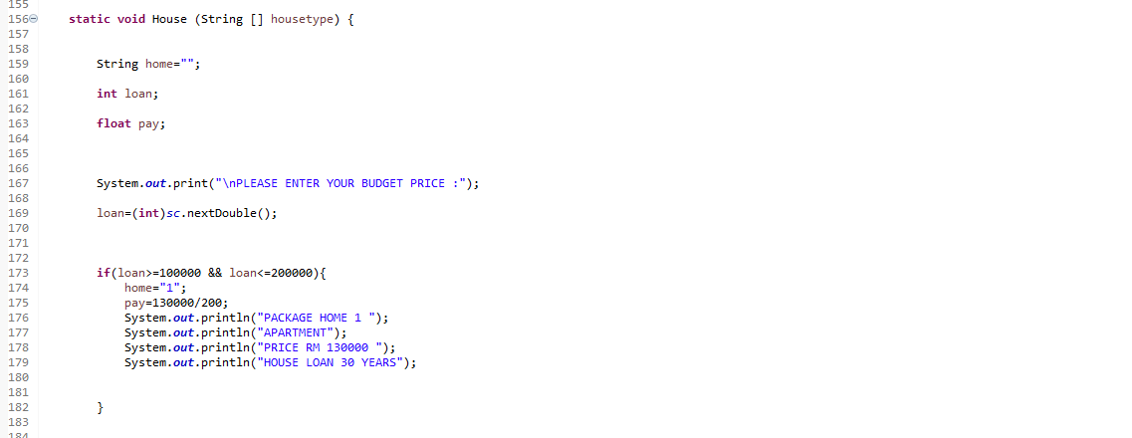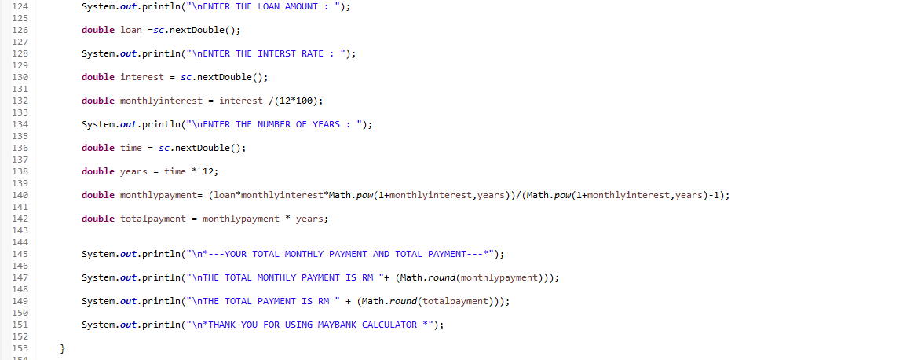

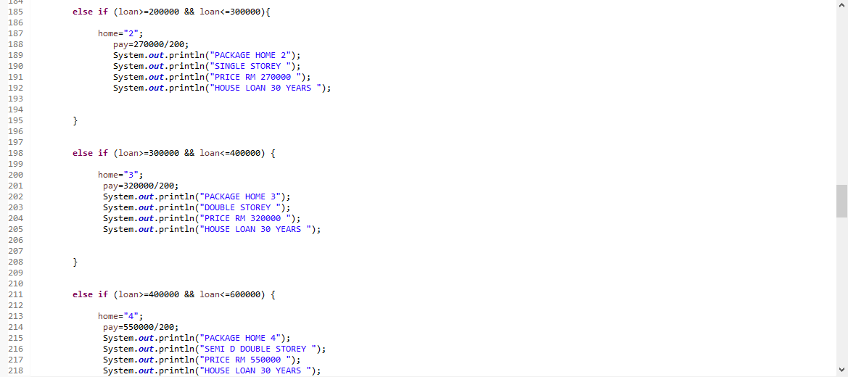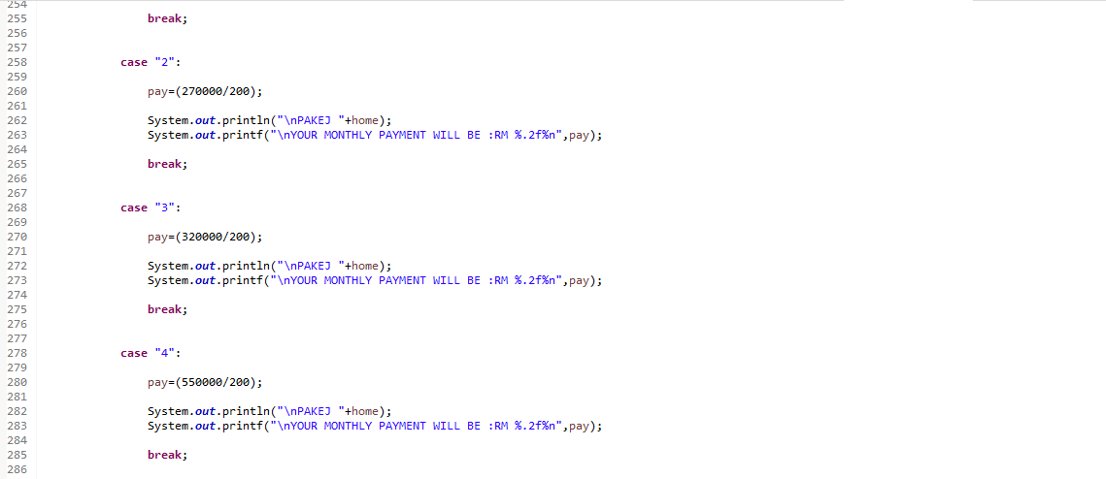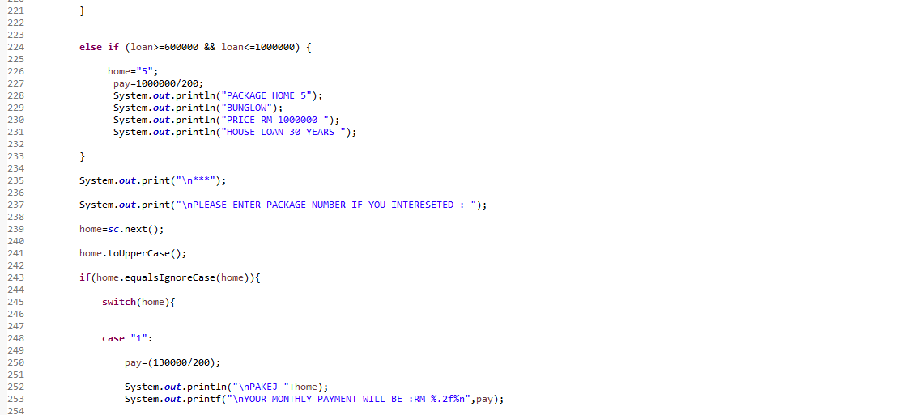

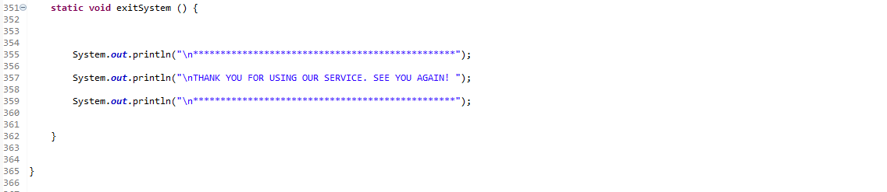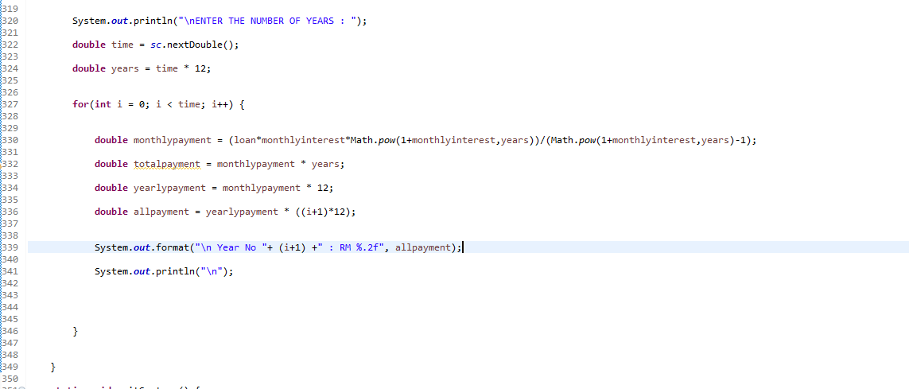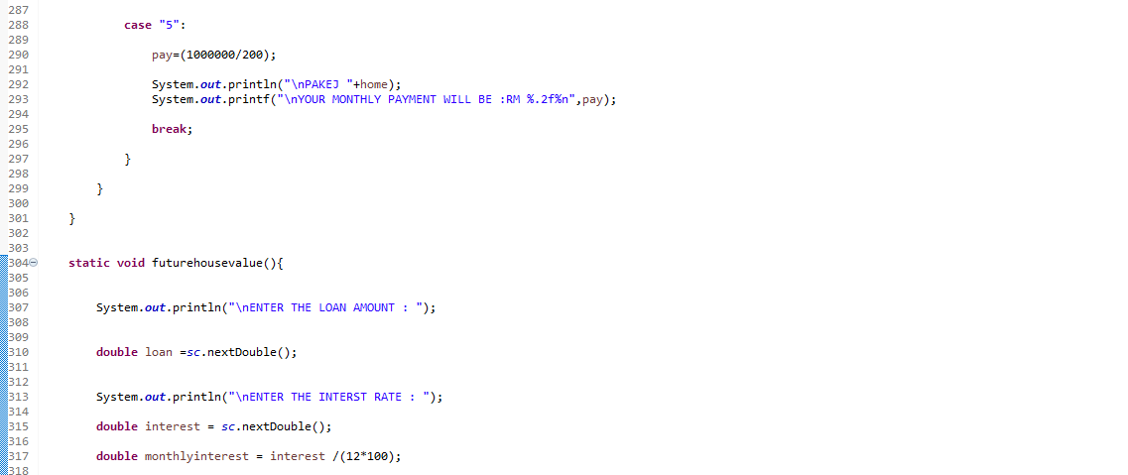

**3.6 Investment**

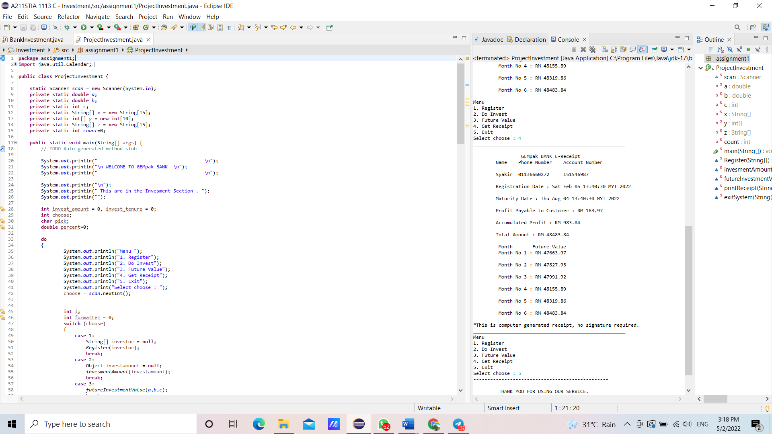 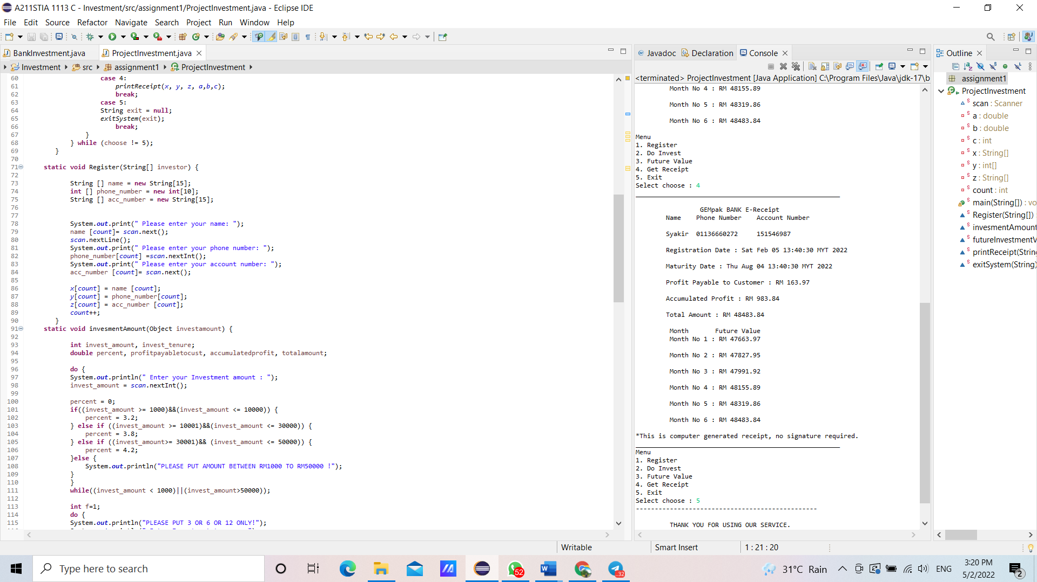

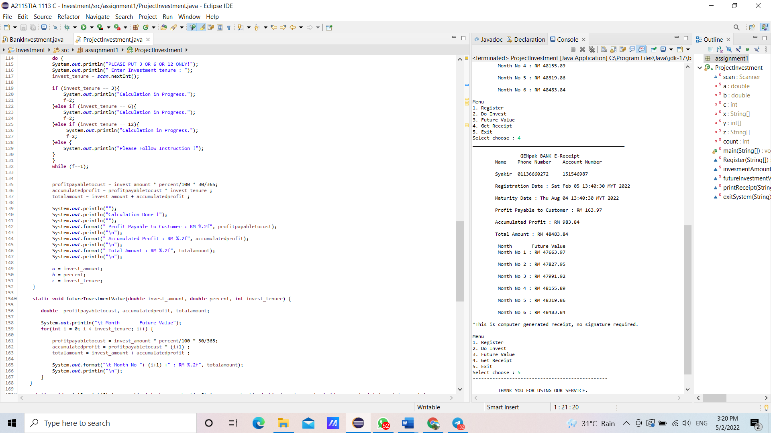

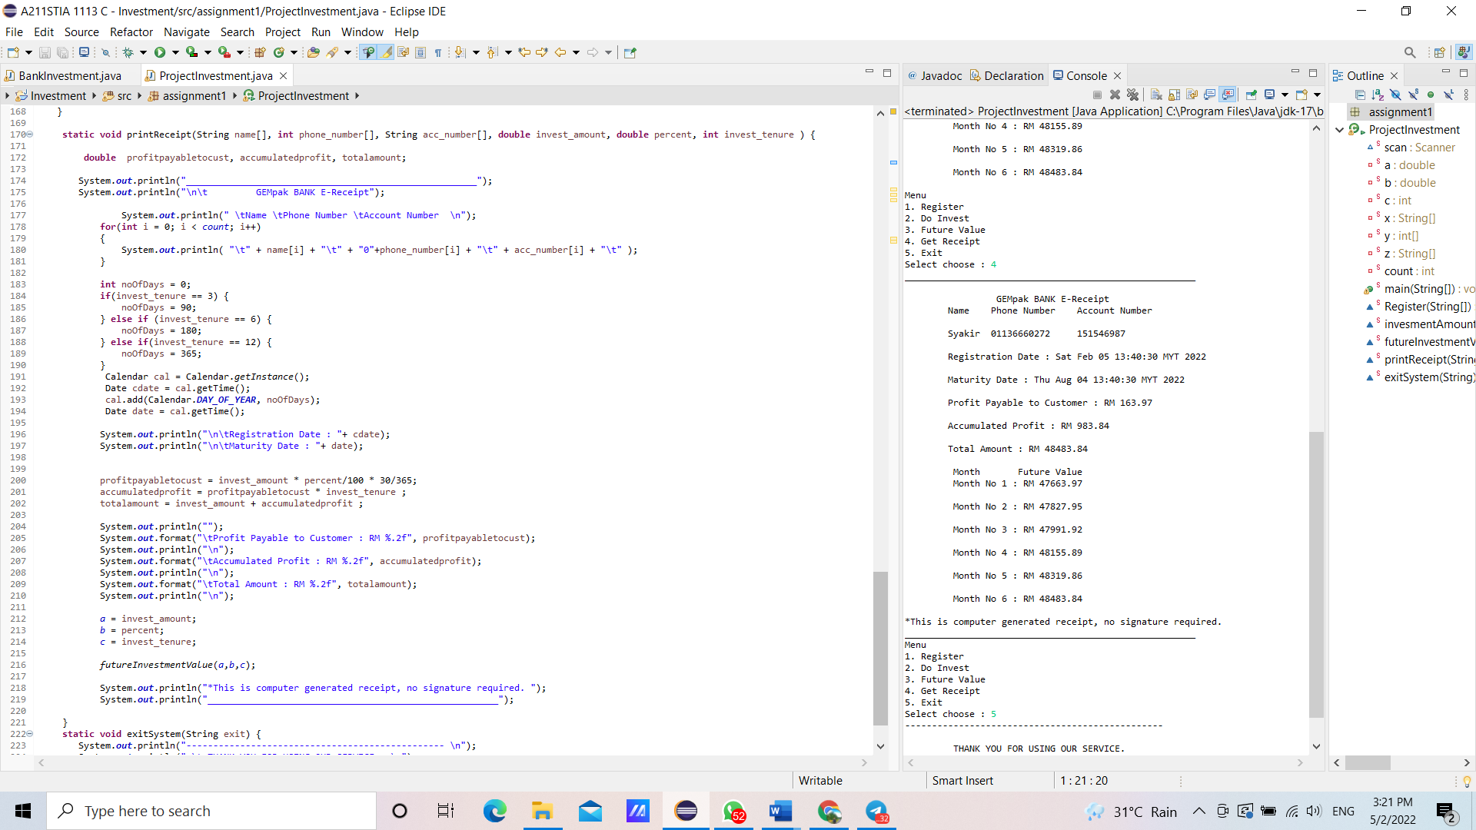 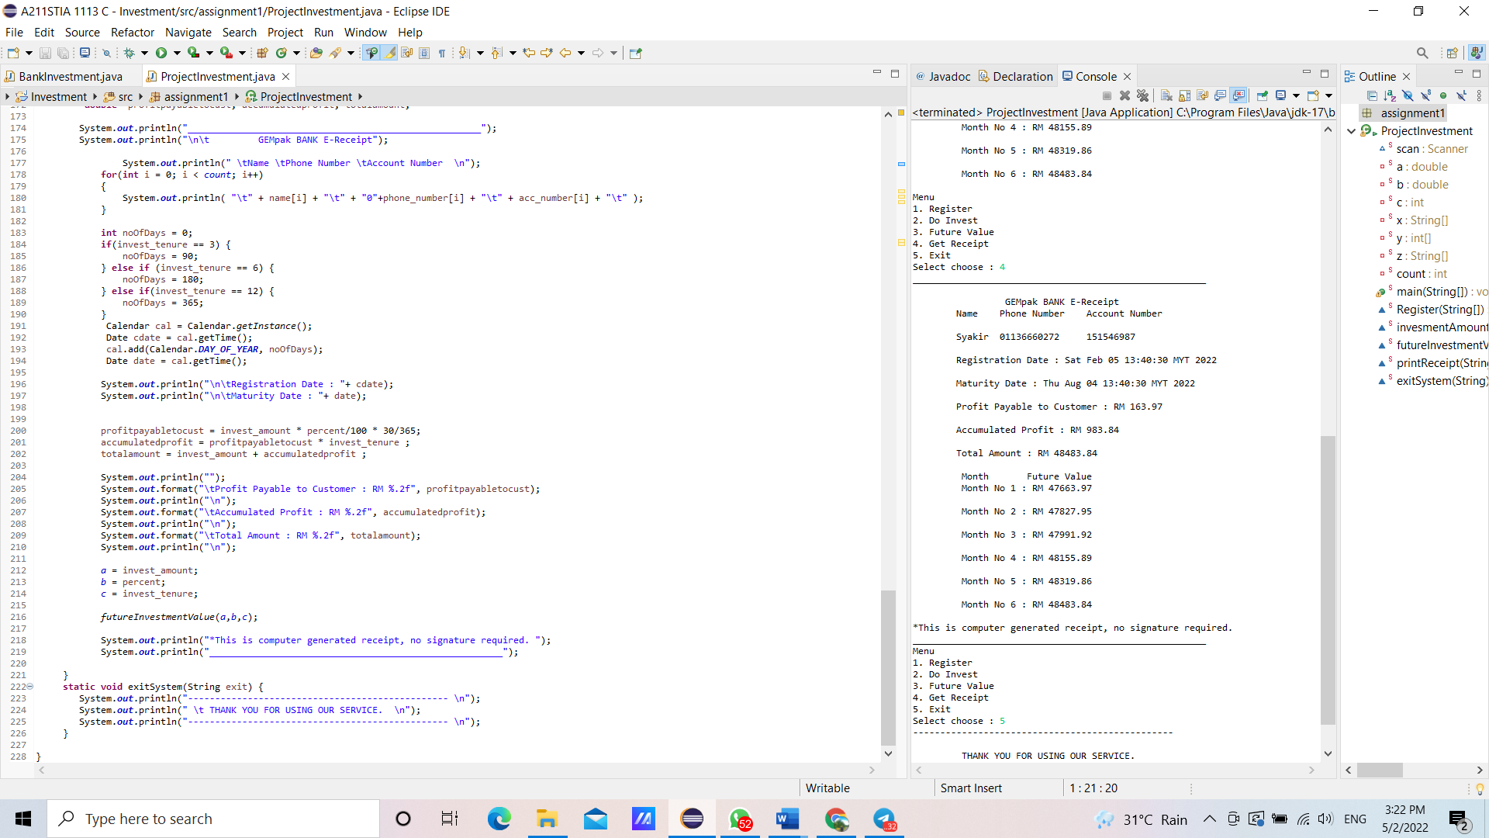

**4.0 Sample Run**

**4.1 Main menu**



**4.2 Business loan**

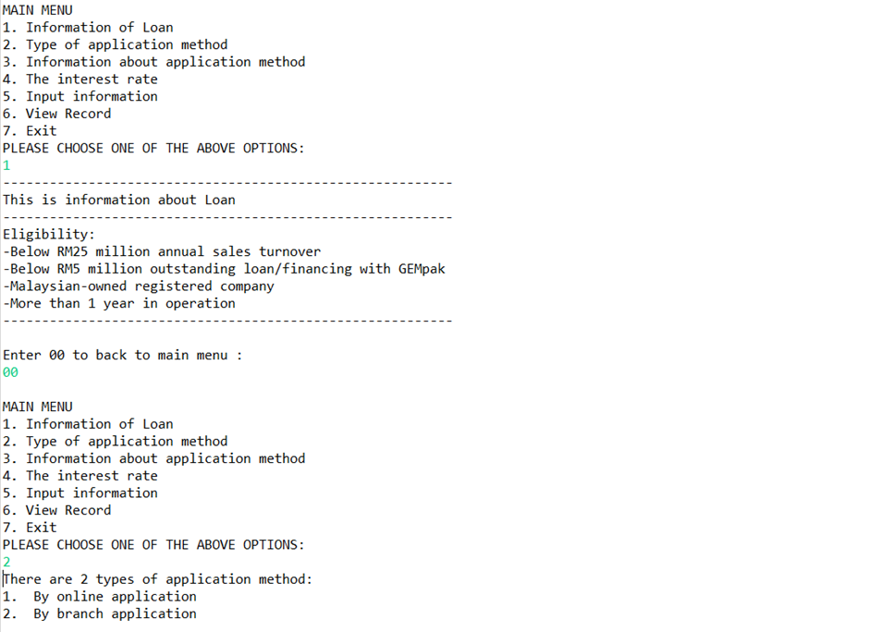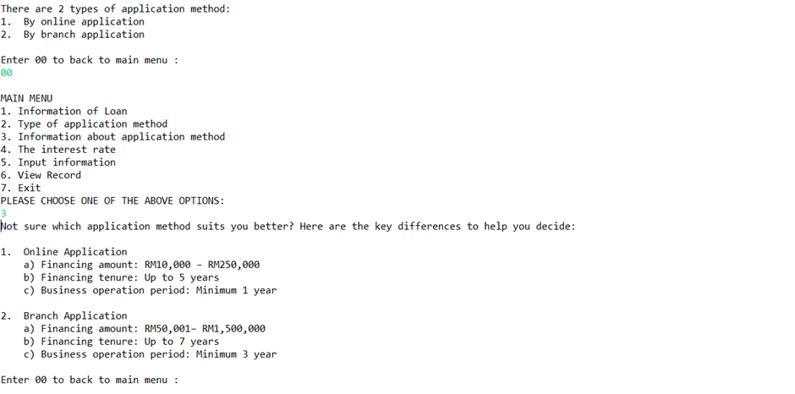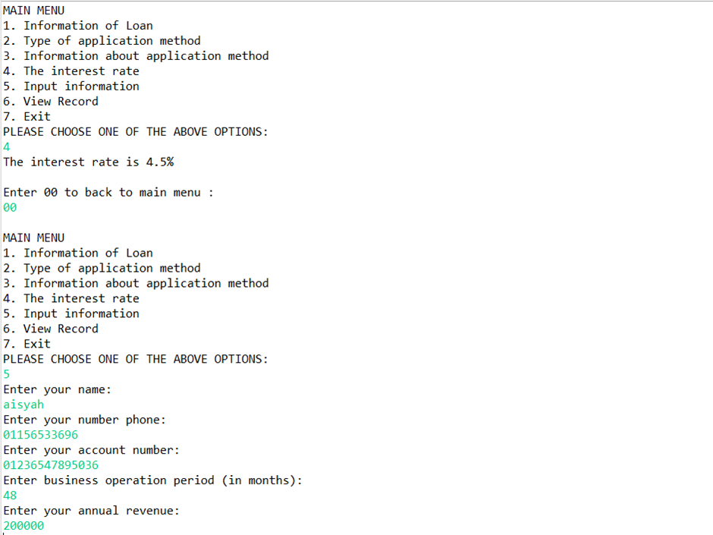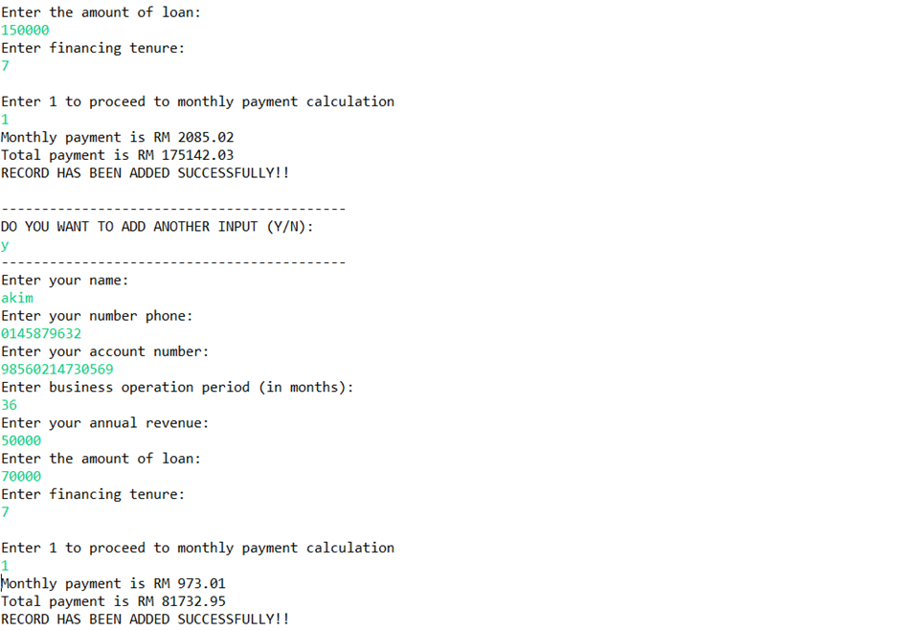

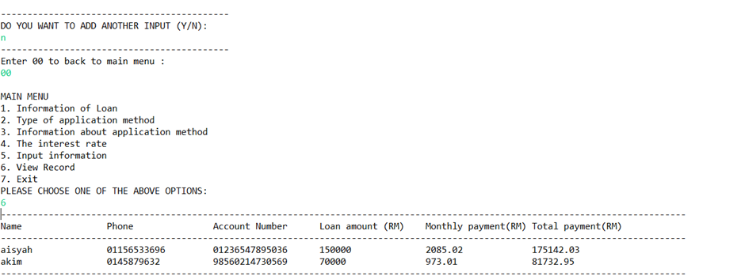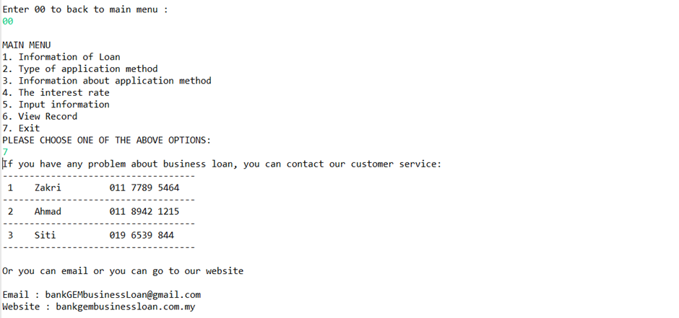

**4.3 Personal account**

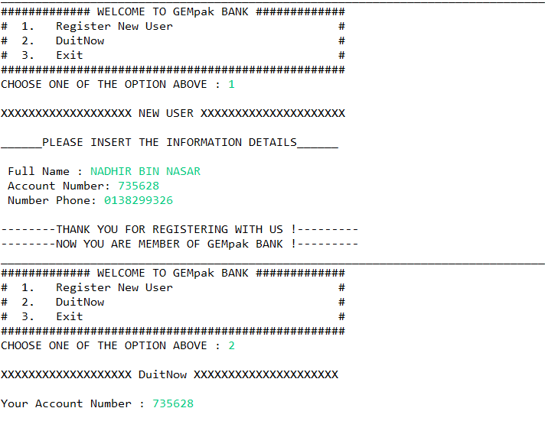

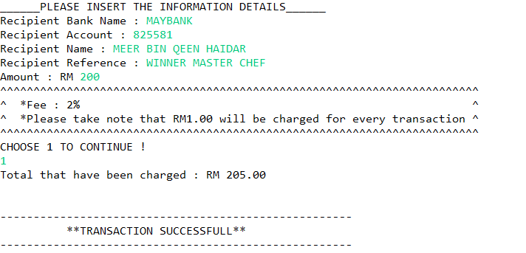

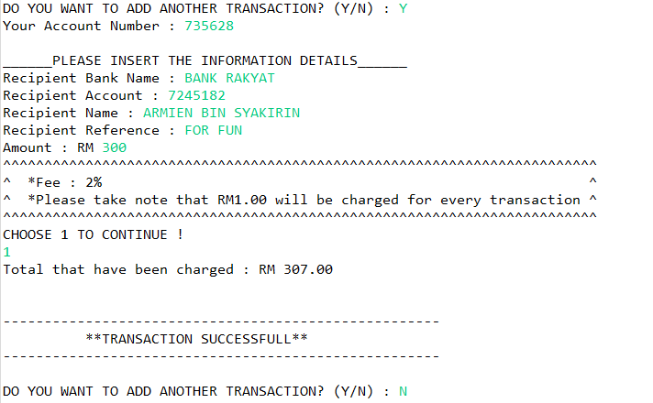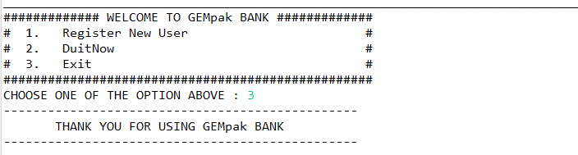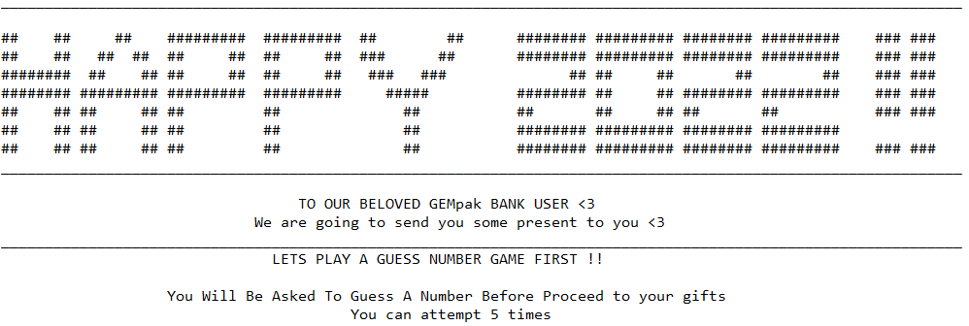

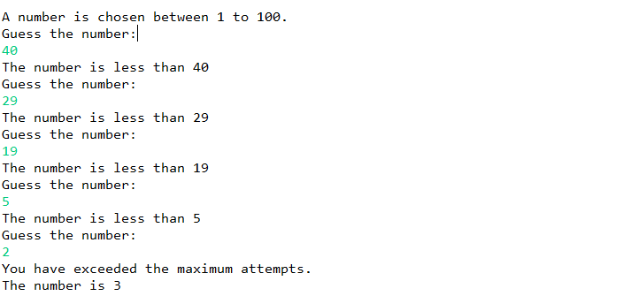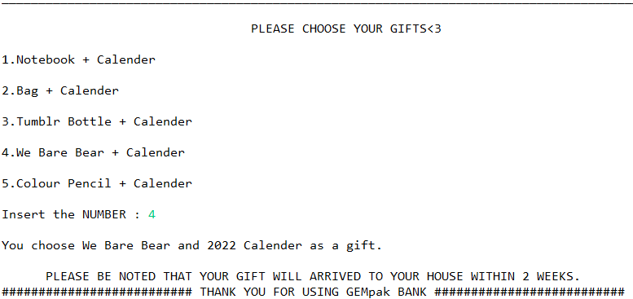

**4.4 Credit card**

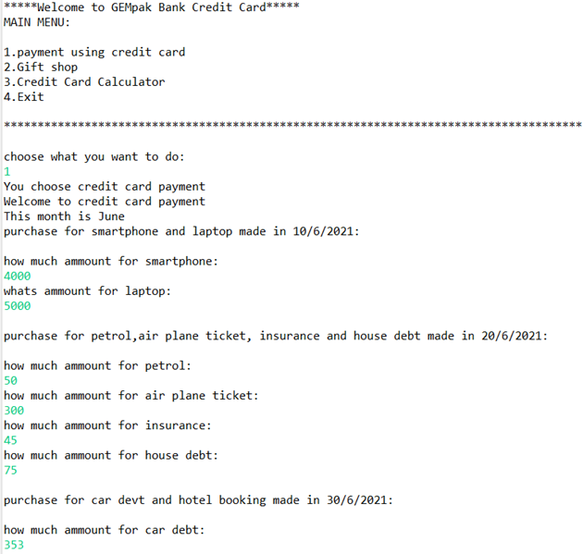

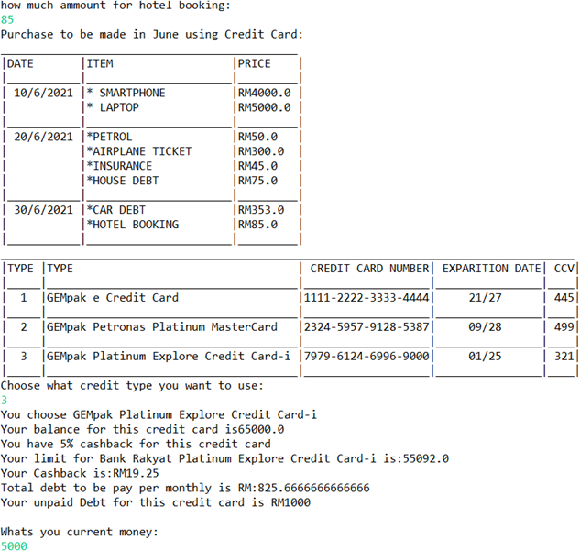

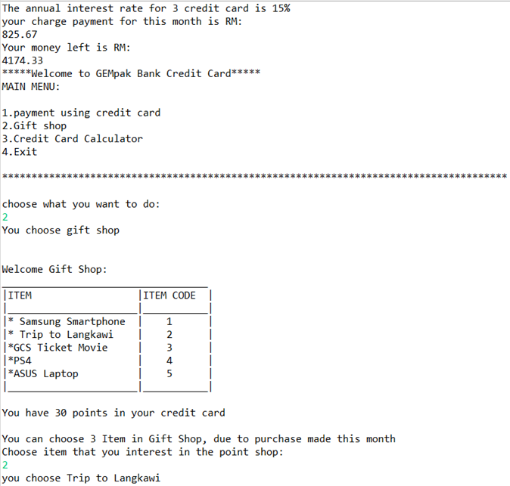

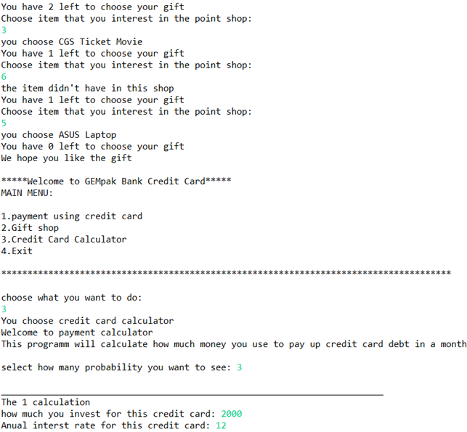

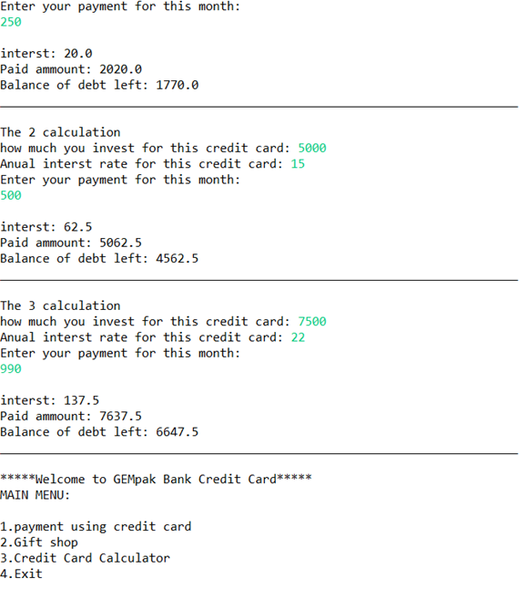

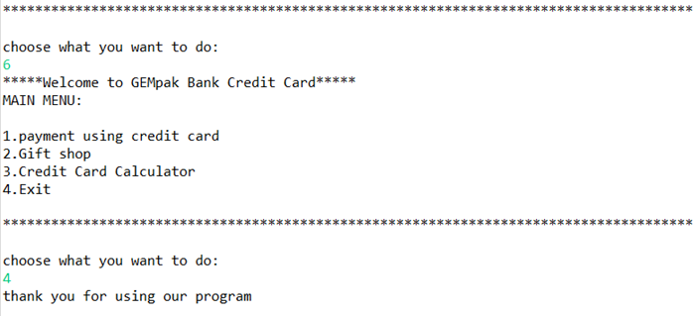

**4.5 Housing loan**

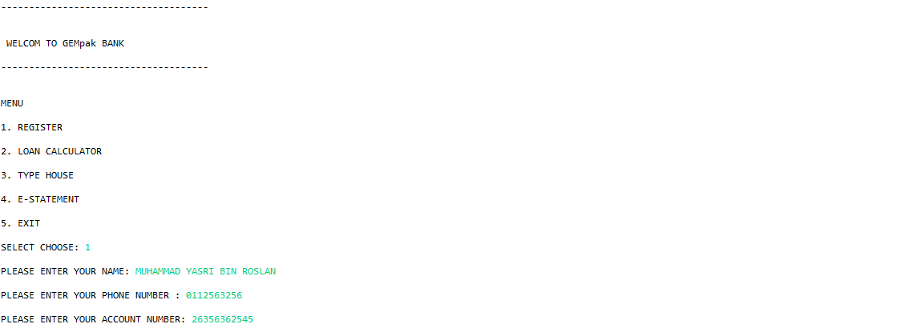

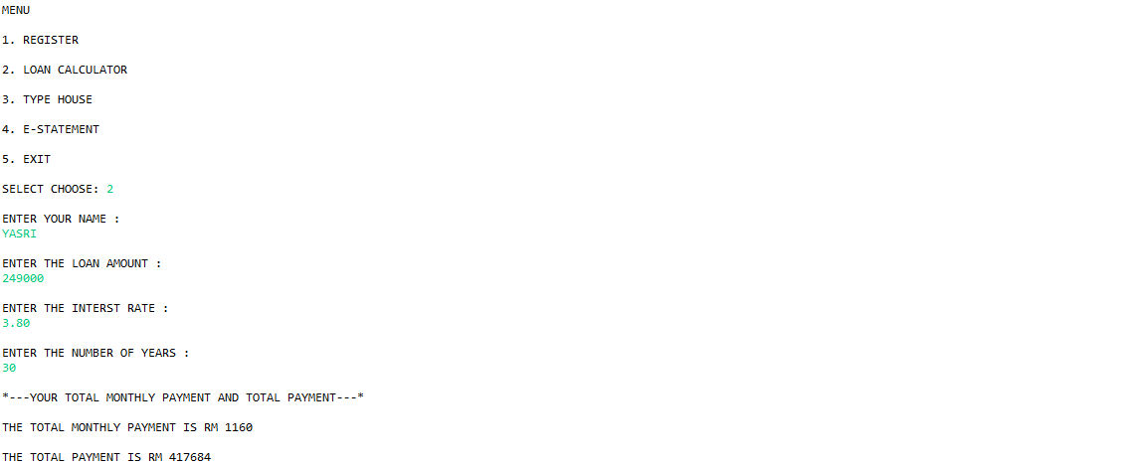



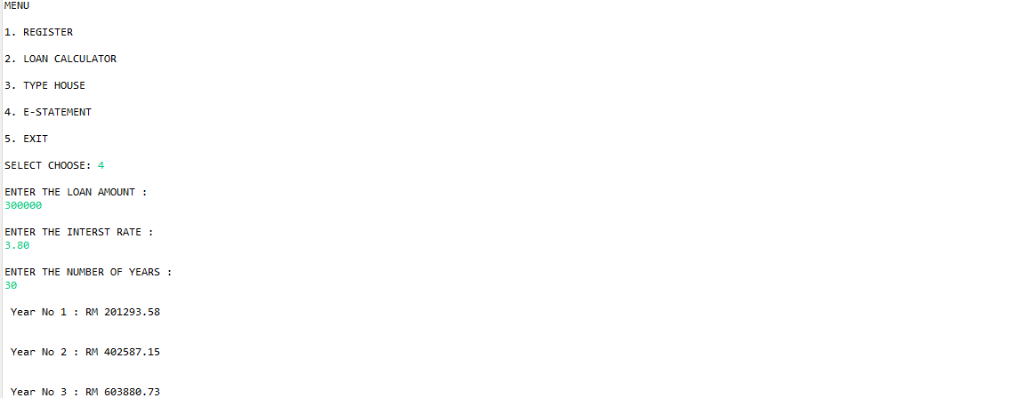

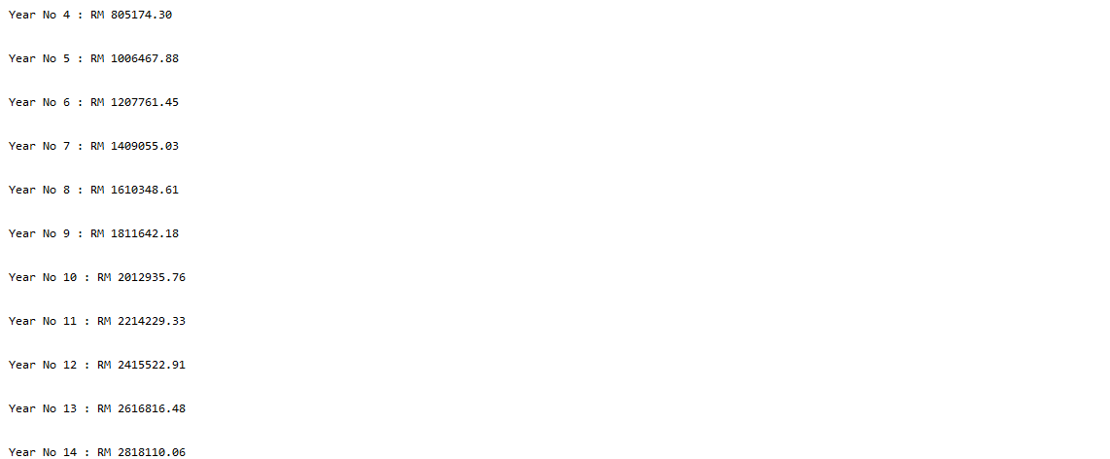





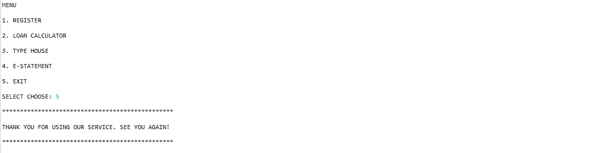

**4.6 Investment**

